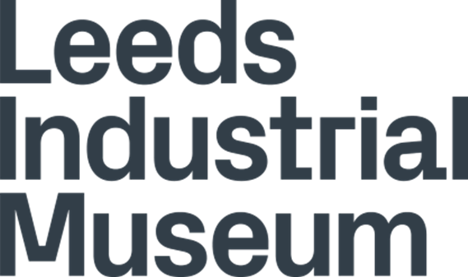

Accessibility Guide for Leeds Industrial Museum
armley.mills@leeds.gov.uk, 0113 378 3173, https://museumsandgalleries.leeds.gov.uk/leeds-industrial-museum/
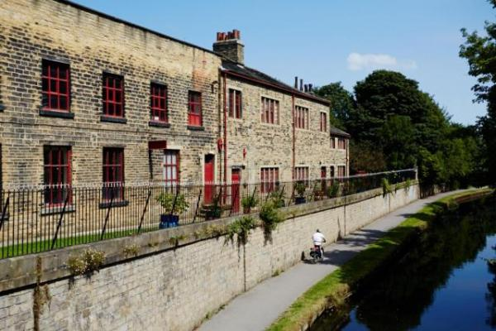

Welcome
Industrial heritage with collections of textile machinery, railway equipment and heavy engineering.

At a Glance

Level Access
- There is level access from the main entrance to:
  - Dining Table
  - Top floor
  - Second Floor
  - Mill Space
  - Cinema
  - Power House
  - Entrance Desk
  - Accessible toilet
  - Shop
  - Colour Garden

Hearing
- Some staff have disability awareness training.

Visual
- Glass doors and full-height windows have contrast markings.
- Some parts of the venue have low lighting.

General
- We have a complimentary ticket policy for personal assistants.
- There is at least 1 public toilet for disabled visitors.
- Some staff have disability awareness training.

Getting here
Leeds Industrial Museum at Armley Mills
Canal Road
Leeds
LS12 2QF

Travel by public transport
- You can get to Leeds Industrial Museum by bus and train.
- The number 14 bus operates from Leeds City Centre and stops on Canal Road. Alternative buses (33, 33A, 508 and 757) travel from the city centre along Kirkstall Road, a short walk from the museum. The footbridge linking the museum to Cardigan Fields/Vue Cinema complex is currently closed. The bus stop is 0.2 miles / 0.3 km from Leeds Industrial Museum.
- The nearest train station is Burley Park. The train station is 1 miles / 1.6 km from Leeds Industrial Museum.
- The nearest train station is Burley Park which is a 1 mile walk from the museum. Leeds train station is 1.6 miles away.

Parking
- We have a car park. There are accessible parking spaces. Parking is free.
- There is a drop-off point at the main entrance. The drop-off point does not have a dropped kerb.
- From the car park to the entrance, there is level access. The path is sloped.
- The route is 3580mm wide, or more.
- Leeds Industrial Museum is located just two miles out of the city centre on Canal Road, off the main A65 road to Kirkstall. Free on-site parking is available and is a 1 minute walk from the entrance.
There is one accessible parking space directly outside the museum entrance.
From the main car park, there is a short walk up the drive and across the bridge and down a slight incline to the main entrance. Over the bridge the floor is cobbled and is slightly uneven.
There is an alternate entrance from the canal. Through a 800mm wide doorway and up 11 stairs and through the Colour Garden to the main entrance.
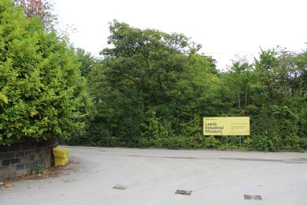
Image showing the car park and sign towards the museum
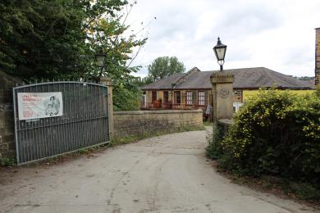
Image showing the bridge towards the museum entrance.
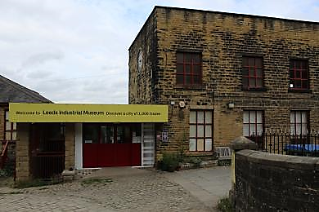
Image showing the entrance to the museum.
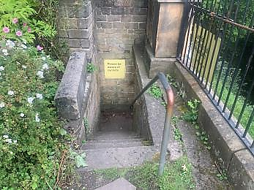
Alternate entrance from the canal showing the steps into the garden.

Arrival

Path to main entrance
- From the street to the main entrance, there is level access.
- The path is 3580mm wide, or more.
- The path is sloped.

Main entrance
- The main entrance has level access.
- The door is 1260mm wide.
- The main door is sliding and automatic.
Image showing entrance with automatic doors.
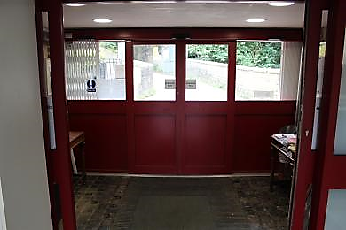
Image showing the automatic sliding doors.

Getting around inside

Visual Impairment - General Information
- We have contrast markings on all glass doors and contrast markings on all full-height windows.
- Some parts of the venue have low lighting.
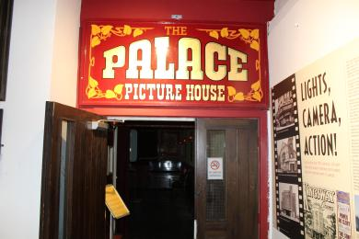
Image showing the Palace Picture House cinema with low lighting
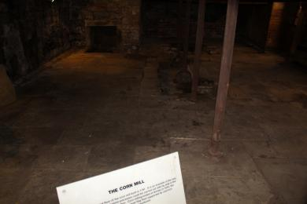
Image showing the old corn mill space with low lighting

Lift
- We have 1 lift.
- You can get a lift to all floors.
- The lift door is 1400mm wide.
- The lift is 1530mm wide. The lift is 4000mm deep.
- The lift is only operated by a member of staff. Please contact a member of staff if you need to use the lift. The maximum weight of the lift is 1000kg. While perfectly safe, the lift is very old and so is noisy and does judder when it reaches a floor.
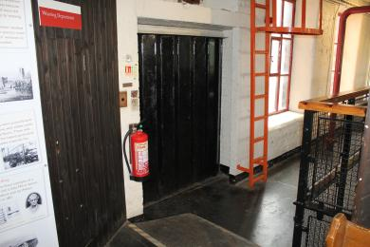
Image showing the outside of the lift on the main floor.
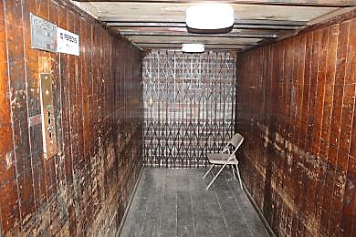
Image showing the inside of the lift with wood panelling walls and a chair.

Ticket/ Entrance Desk
- From the main entrance to the desk, there is level access. The route is 2900mm wide, or more.
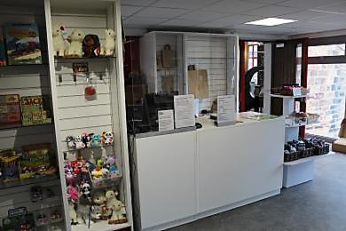
Image showing the entrance desk.

Things to See and Do
- We have a complimentary ticket policy for personal assistants.

Top floor
- From the main entrance to this area, there is level access. The route is 850mm wide, or more. The door is 1350mm wide.
- Some display information is low, for wheelchair users. There are seats.
- Videos have subtitles.
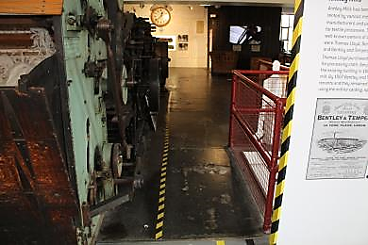
Image showing the start of the top floor route.

Second Floor
- From the main entrance to this area, there is level access. There is a lift.
- From the lift to this area, the route is 1400mm wide, or more. The door is 1450mm wide.
- Some display information is low, for wheelchair users. There are seats.
- Videos have subtitles.
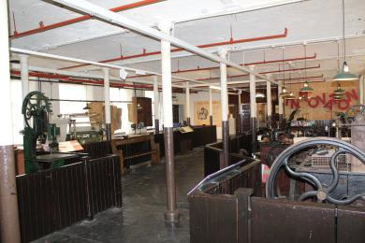
Image showing part of the route on the second floor. Room dressed as a sewing room.
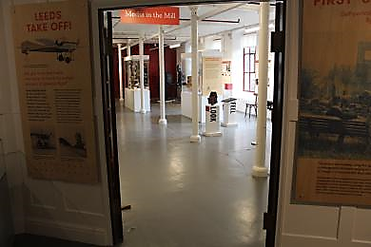
Image showing part of the route on the second floor. Room into printing presses and cameras.

Mill Space
- From the main entrance to this area, there is level access. There is a permanent ramp. There is a lift.
- From the lift to this area, the route is 1400mm wide, or more. The door is 1200mm wide.
- Some display information is low, for wheelchair users. There are seats.
- Videos have subtitles.
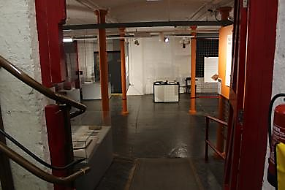
Image showing the Mill Space room from the entrance door.
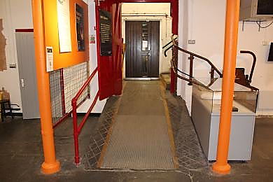
Image showing the ramp going down into the Mill Space area.

Cinema
- From the main entrance to this area, there is level access. There is a lift.
- From the lift to this area, the route is 1400mm wide, or more. The door is 1400mm wide.
- Some display information is low, for wheelchair users. There are seats.
- Videos have subtitles.
- All films are subtitled.
This area is quite dark.
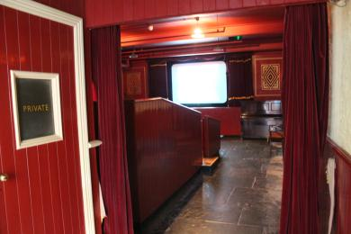
Image showing the inside of the cinema.

Power House
- From the main entrance to this area, there is level access. There is a lift.
- From the lift to this area, the route is 1400mm wide, or more. The door is 950mm wide.
- Some display information is low, for wheelchair users. There are seats.
- Videos have subtitles.
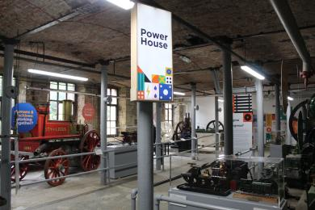
Image showing the inside of the Power House gallery with lots of engines and machines.
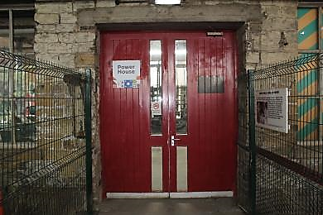
Image showing the outside door to the Power House gallery. It is tall and red.

Accessible toilet
- There is a public toilet for disabled visitors.
- From the main entrance to the public toilet, there is level access. The route is 850mm wide, or more.
- The toilet door is 750mm wide.
- The direction of transfer onto the toilet is to the front only.
- There is 1000mm in front of the toilet. The toilet seat is 430mm high. The toilets have handrails.
- There is an additional accessible toilet located in the Mill Space, accessed by a lift.
There are also babychange facilities in these toilets.
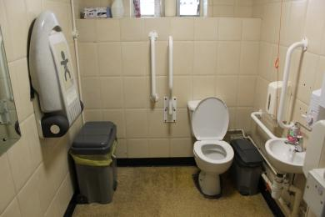
Image showing the inside of the accessible toilet.
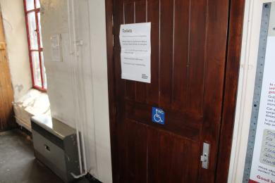
Image showing the door to the accessible toilet.

Shop
- From the main entrance to the shop, there is level access. The route is 2900mm wide, or more. The door is 1260mm wide.
- The route through the shop is 800mm wide, or more.
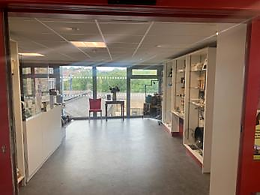
Image showing the shop area. A wide space with shelves and things to buy around the sides.

Place to eat and drink

Community Cafe
- From the main entrance to the dining area, there is level access. The route is 980mm wide, or more. The door is 1320mm wide.
- To get to a table, there are no steps.
- The route through the dining area is 800mm wide, or more.
- There is no background music.
- This is a community space, with self-serve teas and coffees and biscuits.
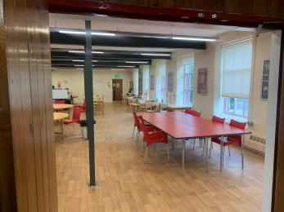
Image showing the community cafe space with tables and chairs.

Getting around outside

Colour Garden
- From the main entrance to the gardens, there is level access.
- The route is 1000mm wide, or more.
- The pathway to the Colour Garden is cobbled and uneven.
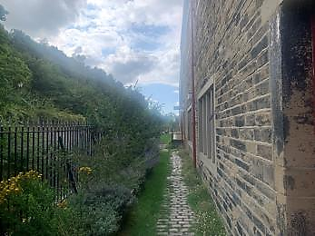
Image showing the narrow cobbled path along the side of the museum towards the Colour Garden.
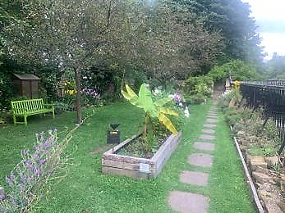
Image showing the Colour Garden with grass and lots of different types of plants.

Customer care support

Accessibility equipment
- We provide wheelchairs. Wheelchairs are free.
- Ear defenders are available near the spinning mule. During the demonstrations of the mule, it can be quite loud and crowded.
Assistance and support animals on leads are welcome, please contact us in advance so we can welcome you properly.
- For a list of more items, please go to https://museumsandgalleries.leeds.gov.uk/leeds-industrial-museum/visit-leeds-....
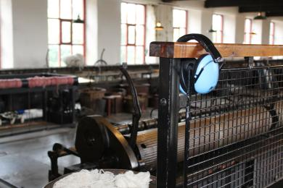
Image showing ear defenders available next to the spinning mule for use during demonstrations.

Emergency evacuation procedures
- We have emergency evacuation procedures for disabled visitors.

Customer care support
- Some staff have disability awareness training.

