Accessibility Guide
discovery.centre@leeds.gov.uk, 0113 378 2100, https://museumsandgalleries.leeds.gov.uk/leeds-discovery-centre/
Contacts for accessibility enquiries: Gemma Brown (Site Development Officer), Emily Nelson (Learning and Access Officer). You can contact Emily and Gemma through the Leeds Discovery Centre email above.

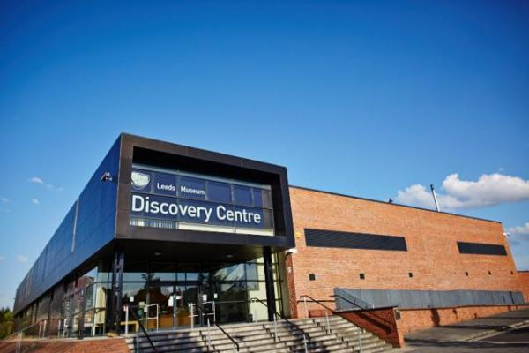

Welcome
The Discovery Centre is home to over one million amazing objects from Leeds Museums and Galleries collections, including dress and textiles, social history, natural science, geology, archaeology, and world cultures. From toucans to telephones, meteorites and masks, there is something for everyone to enjoy.
You can visit us on a free guided tour, in the school holidays, or come as part of an organised group. You can hire us as a conference venue. Visiting the Leeds Discovery Centre guarantees you a unique experience.
Please get in touch if you require further information about specific access or need advice on planning your visit.

At a Glance

Level Access
- The main entrance has level access with a ramp. The ramp is permanent.
- There is level access from the main entrance to:
  - Main Corridor and Collections Store entrance
  - Collections Store Lobby
  - Collection Store
  - Workshops in the Discovery Space
  - First Floor Meeting Room
  - Reception Desk
  - Ground Floor Accessible Toilet
  - Baby Change Facilities
  - Fire Assembly Point

Hearing
- The fire alarm has flashing lights.
- We have a hearing loop in The Reception area and Discovery Space conference room.
- Some staff have disability awareness training.

Visual
- Some parts of the venue have low lighting.

General
- There is at least 1 public toilet for disabled visitors.
- Some staff have disability awareness training.

Getting here
Carlisle Road
Leeds
LS10 1LB

Travel by public transport
- You can get to Leeds Discovery Centre by car, bus, train or boat.
- The nearest bus stop is on Hunslet Road. It is serviced by the numbers 13, 12 and Park and Ride 2. The bus stop is 0.20 miles / 21.1 km from Leeds Discovery Centre.
- The nearest train station is Leeds Train Station. The train station is 1.1 miles / 1.8 km from Leeds Discovery Centre.
- There is a Water Taxi which runs from the back of Leeds Train Station to Leeds Dock every day weather permitting, 10am-6pm. This costs £2 per person and accepts card payments only. This is not accessible for any users with mobility needs.

Travel by taxi
- You can get a taxi with South Leeds and Hunslet Cars by calling 0113 2777 222. The taxi company has a wheelchair accessible vehicle.
- You can get a taxi with City Cabs Leeds by calling 0113 246 9999. The taxi company has a wheelchair accessible vehicle.
- You can get a taxi with Amber Cars by calling 0113 202 2117. The taxi company has a wheelchair accessible vehicle.

Parking
- We have a car park. There are accessible parking spaces. The car park is less than 50 metres from the main entrance. Parking is free.
- There is a drop-off point at the main entrance. The drop-off point has a dropped kerb.
- From the car park to the entrance, there is level access. There is a permanent ramp.
- The path is sloped.
- The route is 2300mm wide, or more.
- The car park is accessed from Sayner Lane, at the back of the building.
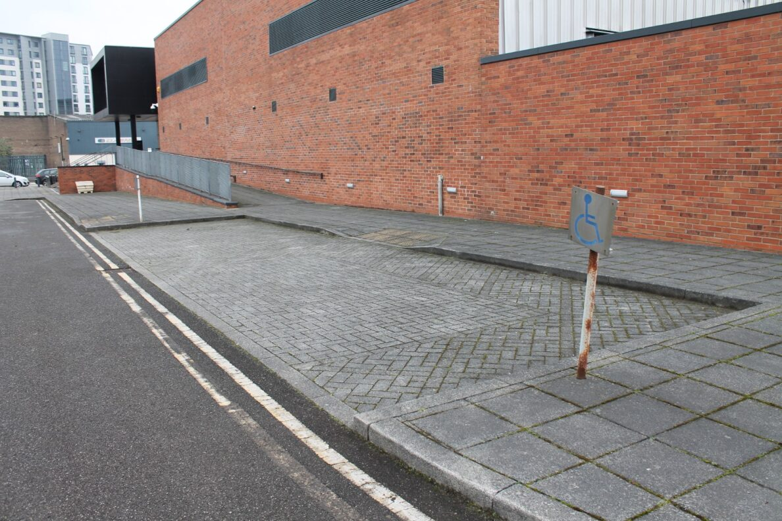
Exterior image of Leeds Discovery Centre car park disabled parking bays and ramp access to entrance.

Arrival

Path to main entrance
- From the street to the main entrance, there is level access.
- There is a permanent ramp.
- The path is 2300mm wide, or more.
- The path is sloped.

Main entrance
- The main entrance has level access.
- There is a permanent ramp.
- The door is 1160mm wide.
- The main door is sliding and manual.
- The front door is semi-automatic, a member of staff will open the door for you from the reception desk. If the desk is not occupied, please press the doorbell which is to the right of the door for attention.
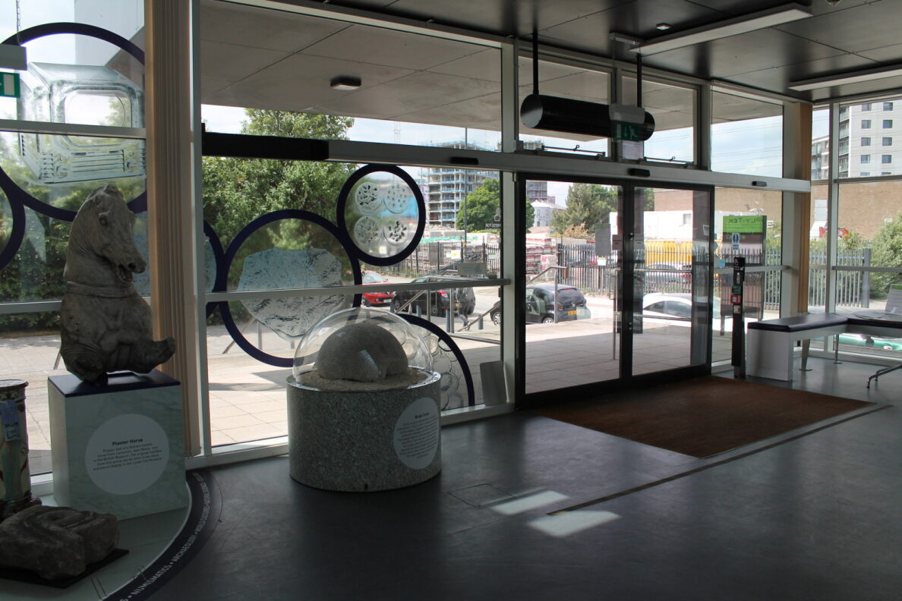
Interior views of the Reception area and front door.
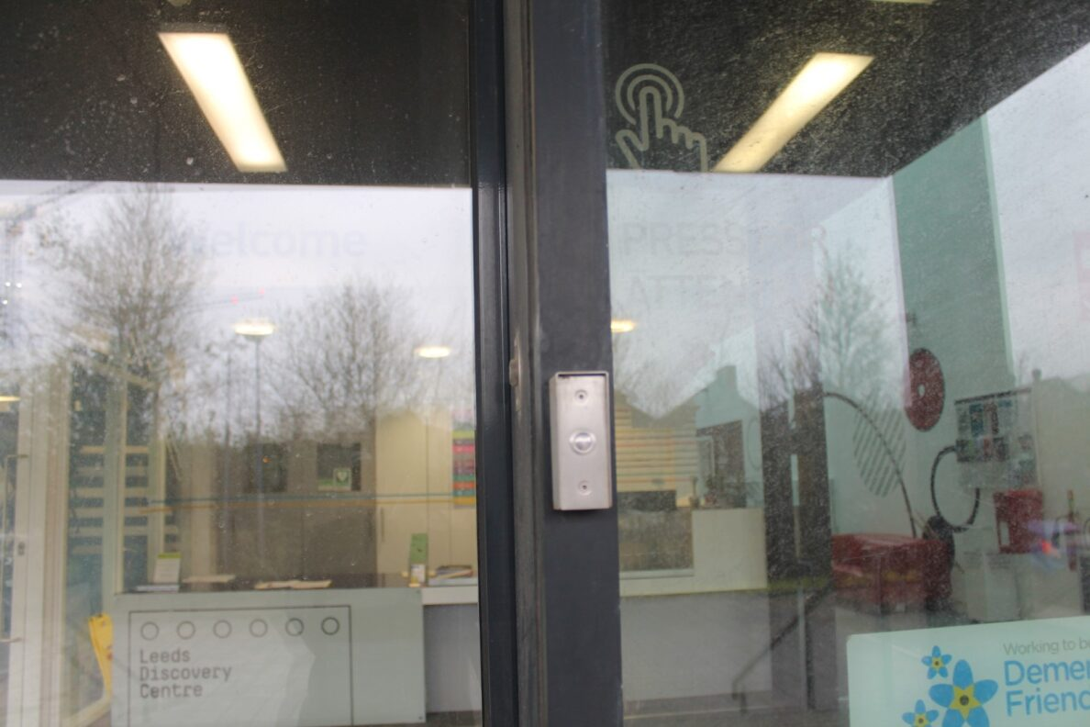
Doorbell and sign at the front door, to the right-hand side.

Getting around inside

Visual Impairment - General Information
- Some parts of the venue have low lighting.
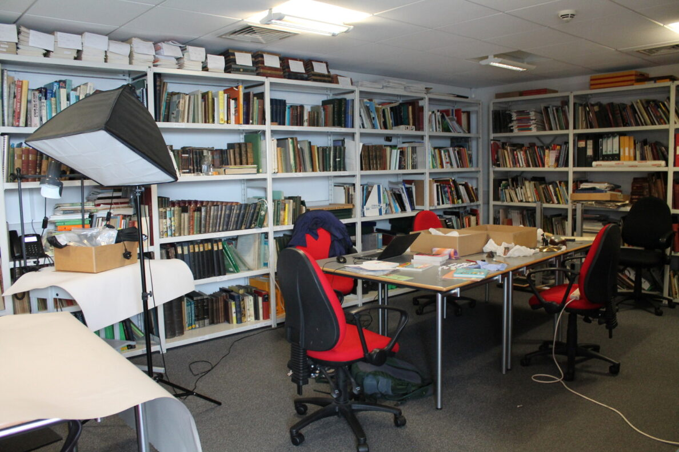
Image of the research room in use. It has low level lighting.

Lift
- We have 1 lift.
- You can get a lift to all floors.

Lift to First Floor
- The lift door is 900mm wide.
- The lift is 1100mm wide. The lift is 1400mm deep.
- The lift says the floor number at each floor.
- The lift buttons have raised numbers or letters.
- The lift shows the floor number, at each floor.
- Although the lift has buttons up to the number 9, the building only has 2 floors, the Ground Floor and First Floor.
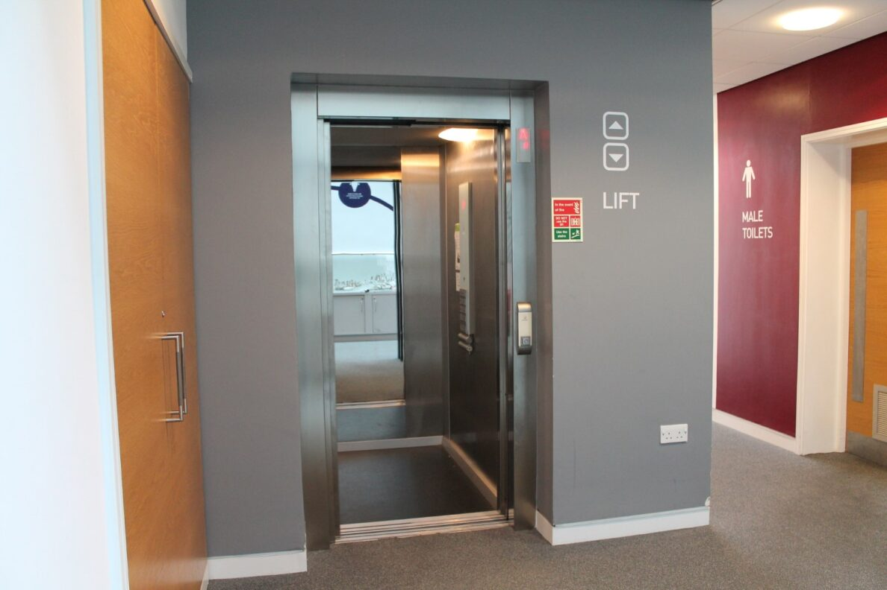
Lift signage and interior

Ticket/ information desk

Reception Desk
- From the main entrance to the desk, there is level access. There is a permanent ramp.
- There is bench seating available in this area. The area is well and evenly lit. There is a hearing loop at the Reception desk. If required, assistance can be given through magnifying glasses or pens and pads of paper.
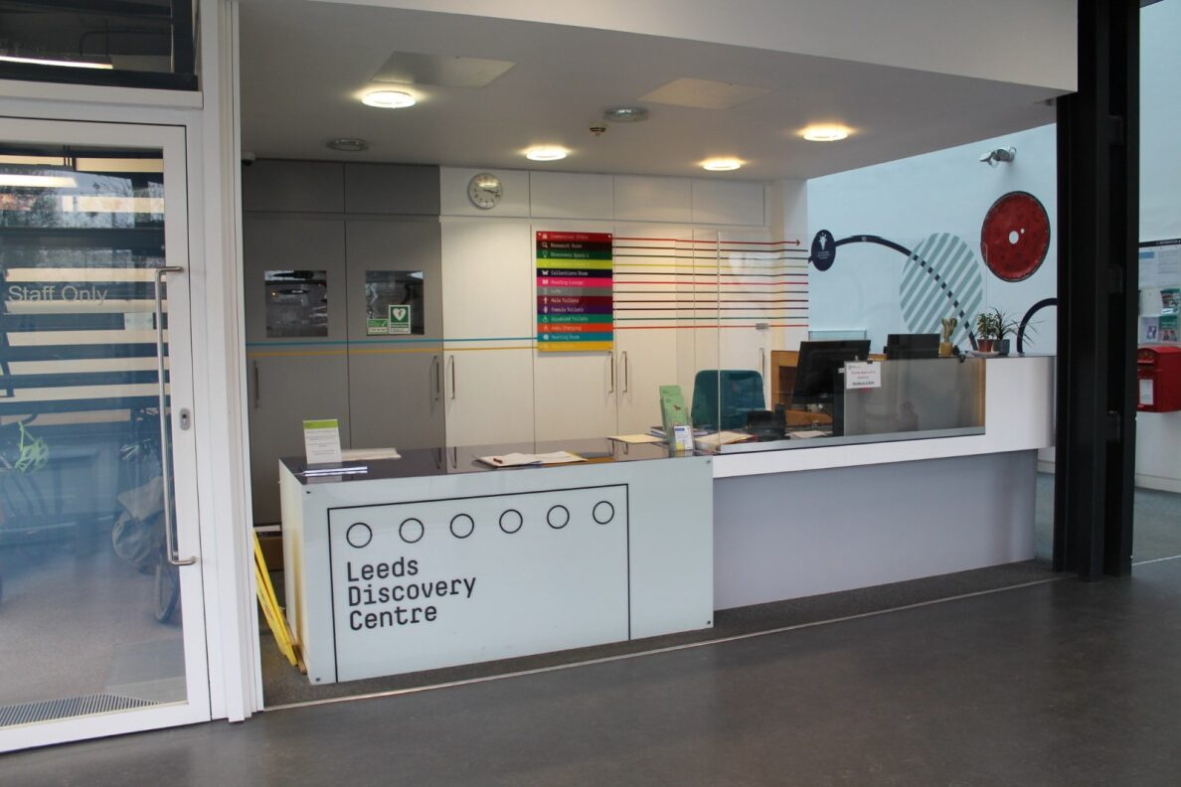
The reception desk at the Discovery Centre

Things to See and Do
- You may be visiting for a public tour. Relaxed and touch tours and visits can be arranged in advance. There are objects which you can look at in the entrance and down the corridor.

Main Corridor and Collections Store entrance
- From the main entrance to this area, there is level access. The route is 1820mm wide, or more. Some display information is low for wheelchair users. There are seats.
- From the reception area visitors begin their guided tour along the main corridor viewing display cases with objects inside. The floor is carpeted. Visitors will stop outside the main entrance to the store for the next part of the tour.
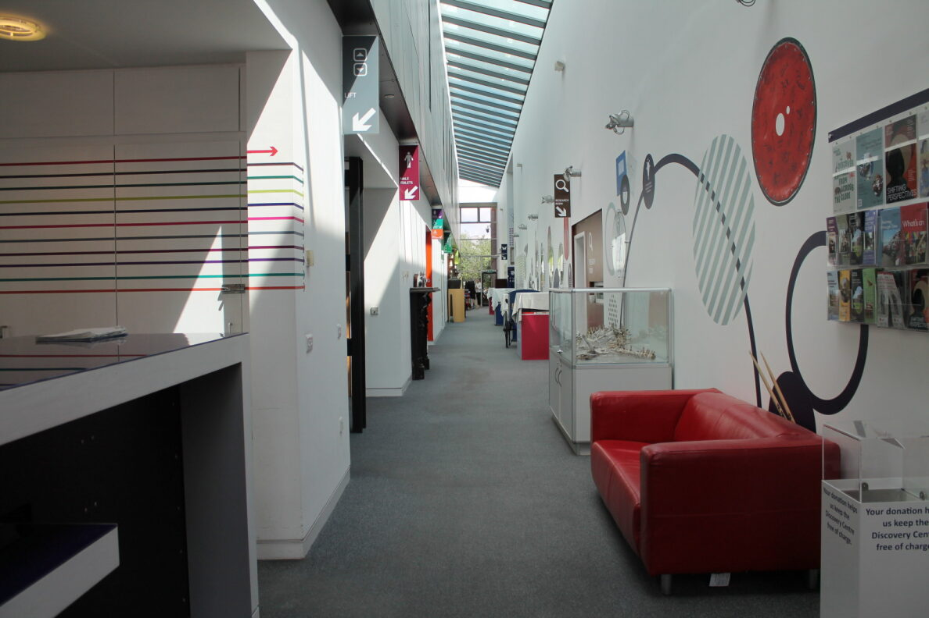
View of main corridor towards the Collections Store entrance
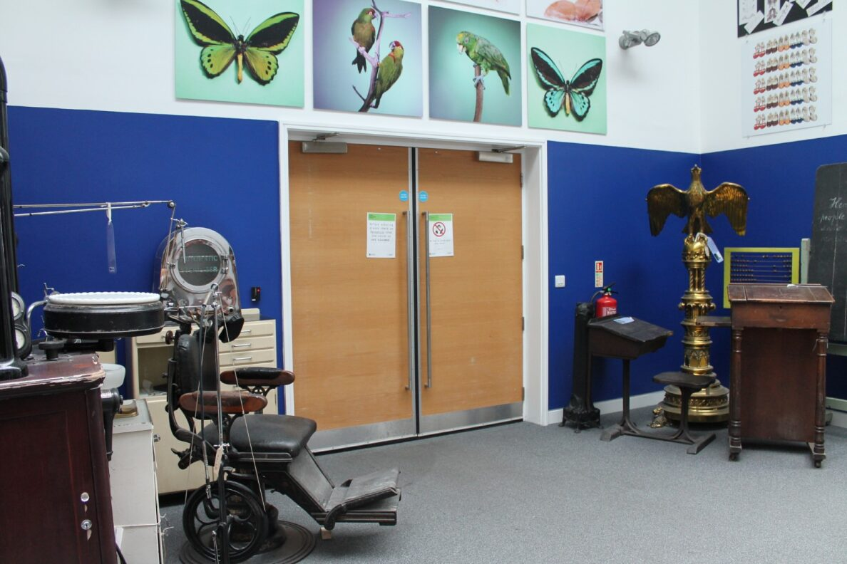
Entrance to the collections store

Collections Store Lobby
- From the main entrance to this area, there is level access. The route is 1820mm wide, or more. The door is 830mm wide.
- Some display information is low for wheelchair users.
- The lobby area has no natural light, lights are ceiling mounted and at a low level. Around the perimeter of the lobby are museum objects on open display.
- When the door is opened it may be dark inside. The lights come on automatically when you enter.
- There is a loud beep when the door opens.
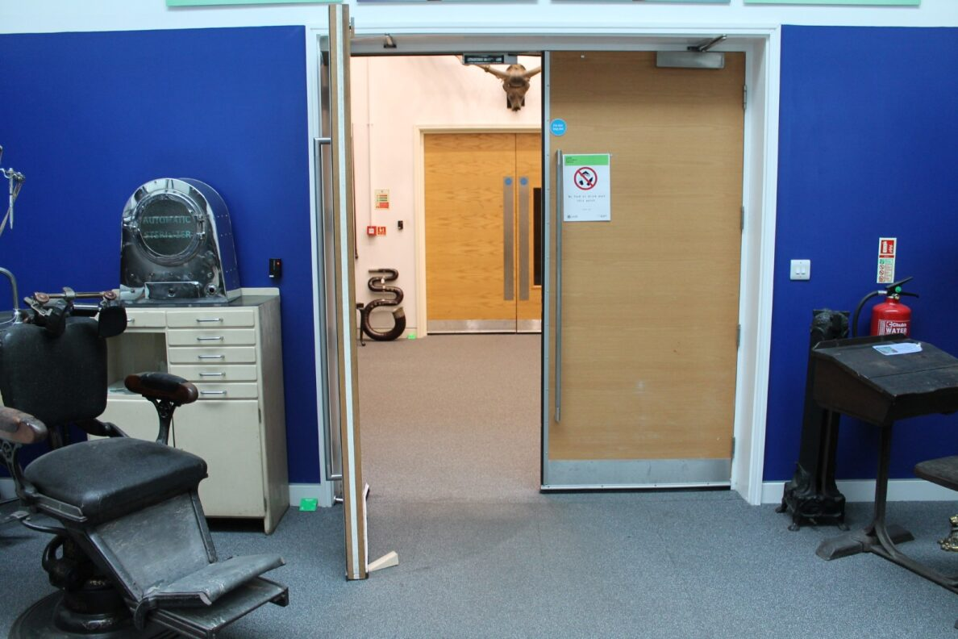
Door from corridor into the lobby area.
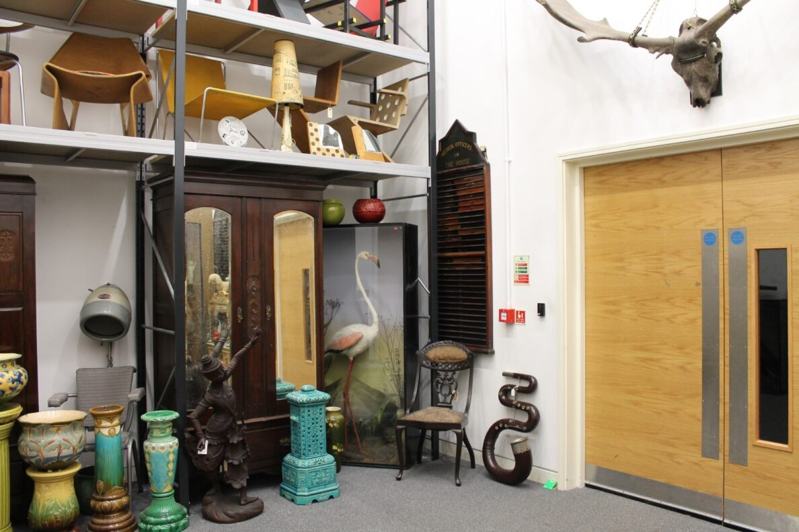
Inside the lobby, with doors into the main collections store

Collection Store
- From the main entrance to this area, there is level access. The route is 1820mm wide, or more. The door is 870mm wide.
- Some display information is low for wheelchair users. There are seats at intervals around the store. These can be moved and positioned where required.
- There is a loud beep when the door opens.
- The lights may be off when the door is opened. They are turned on by a member of staff. There is no natural light.
- The collection store is kept at 16 degrees Celsius for the care of the museum objects. The humidity level is kept at 45-55% rh. Jackets or jumpers are suggested. The floor is painted concrete. Chairs are available to visitors during the store tour. The tour will move around the store looking at objects and exiting the store via the same entrance door.
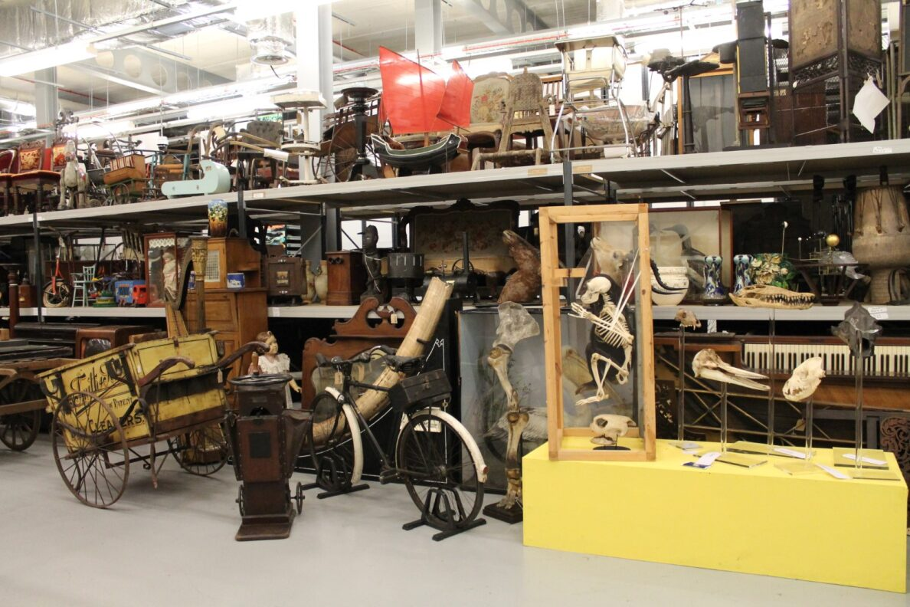
Inside the collections store
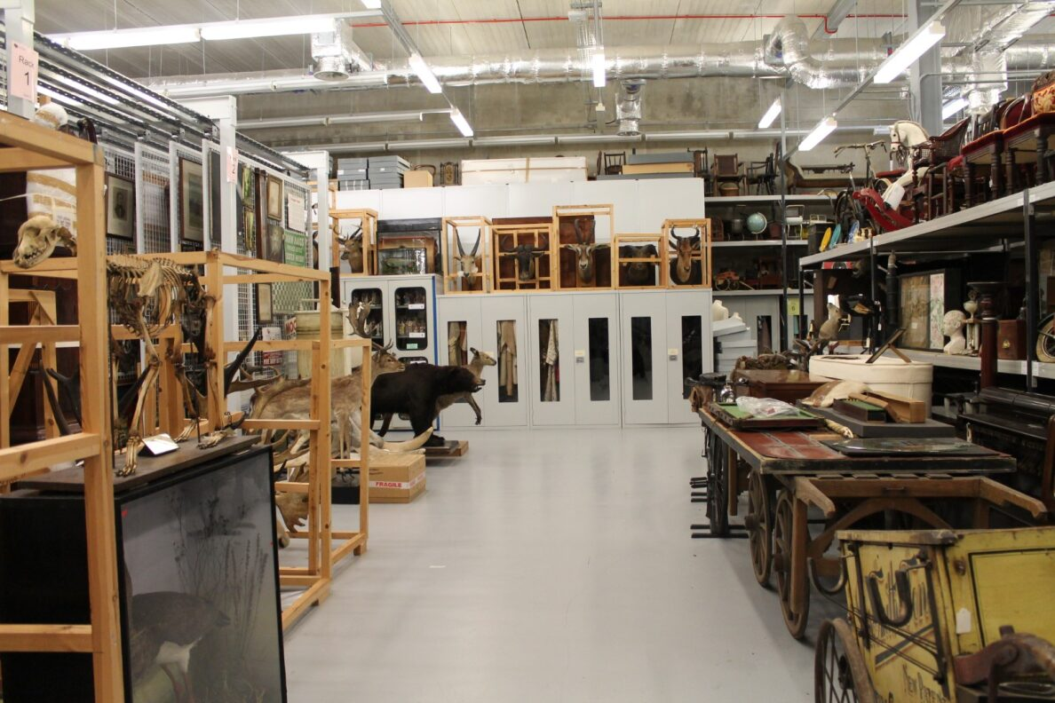
Museum objects in the collection store
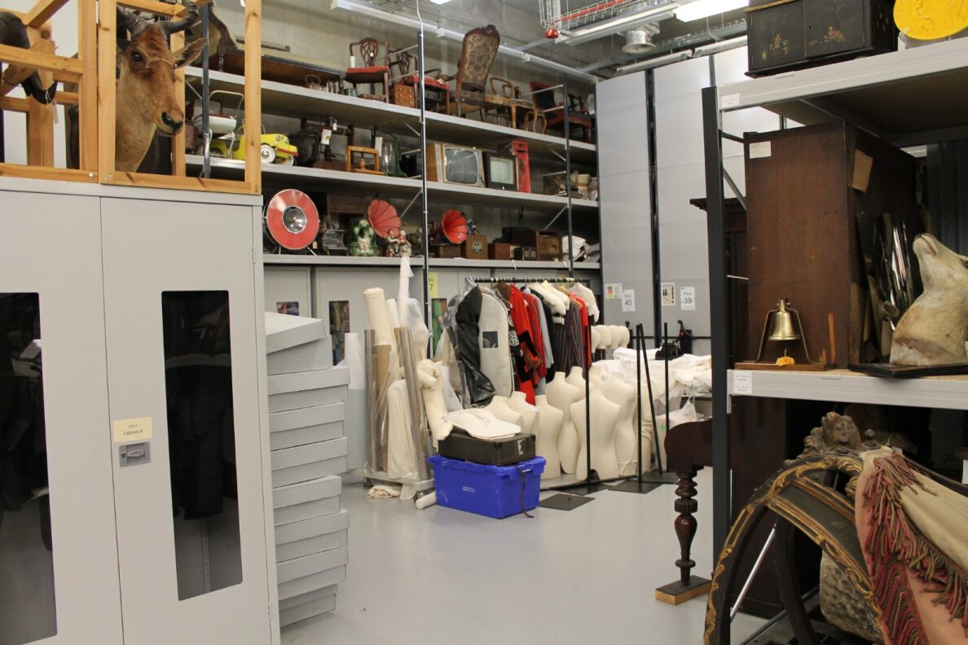
Different methods to store museum objects

Workshops in the Discovery Space
- From the main entrance to this area, there is level access. The route is 1820mm wide, or more. The door is 900mm wide.
- Some display information is low for wheelchair users. There are seats.
- There is a hearing loop.
- School workshops, family sessions, community workshops and conferences are held in the Discovery Space on the ground floor. The room has a lino floor covering. The room is well and evenly lit with floor to ceiling windows. Windows do not have contrast markings. The Discovery Space can be split into two by a partition wall. This is an acoustic wall, but loud sounds from one side of the room can carry.
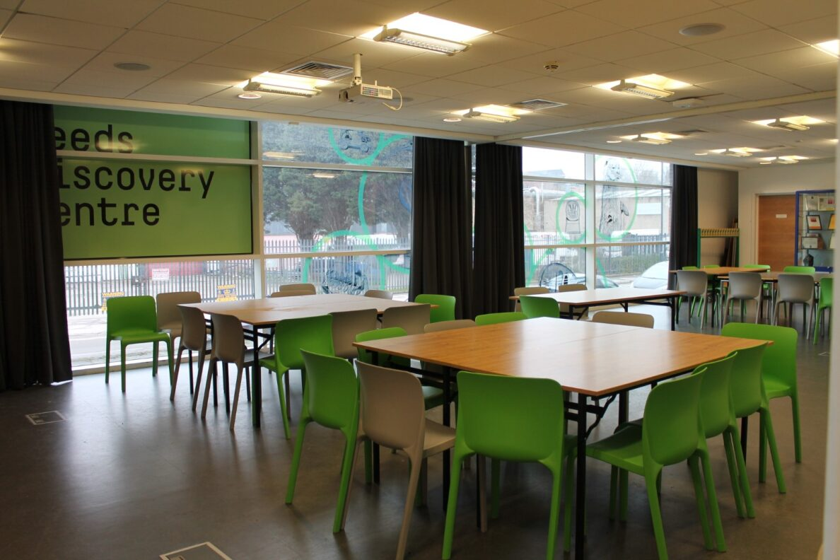
View of the Discovery Space set out for a workshop

First Floor Meeting Room
- From the main entrance to this area, there is level access. There is a lift.
- From the lift to this area, the route is 1850mm wide, or more. The door is 860mm wide.
- From the main entrance to this area, there are 22 steps. There is no lift and no ramp.
- There are seats.
- The first-floor meeting room is used as a conference venue. The seats are height and back adjustable. The room is well lit with natural light from the floor to ceiling windows. The floor is carpeted.
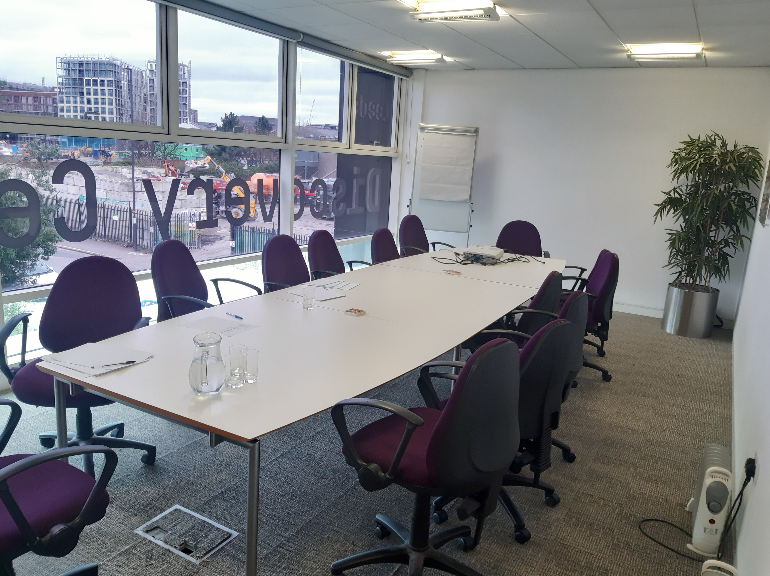
First floor meeting room

Public toilets

Ground Floor Accessible Toilet
- There is a public toilet for disabled visitors.
- From the main entrance to the public toilet, there is level access. The route is 1840mm wide, or more.
- The toilet door is 910mm wide.
- The direction of transfer onto the toilet is to the left.
- There is 940mm at the side of the toilet. There is 1430mm in front of the toilet. The toilet seat is 470mm high. The toilets have handrails.
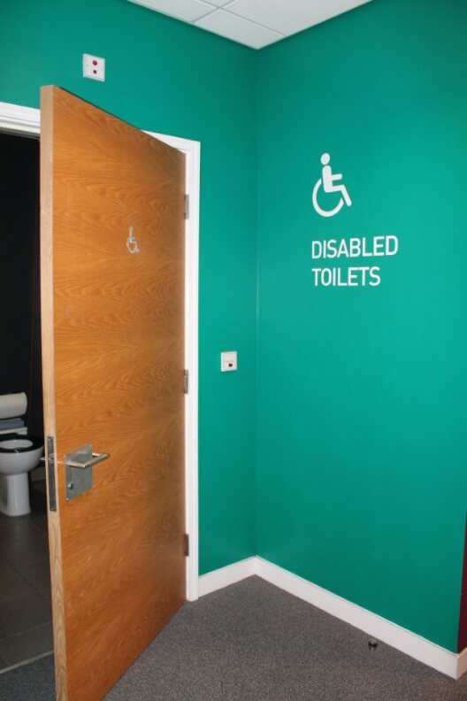
Signage and view of ground floor toilet

Baby Change Facilities
- From the main entrance to this area, there is level access. The route is 1840mm wide, or more.
- The door is 900mm wide.
- The baby changing facilities are located on the ground floor in a separate room from the accessible toilet. Inside the room is a wall mounted table, hand basin, nappy bin and chair.
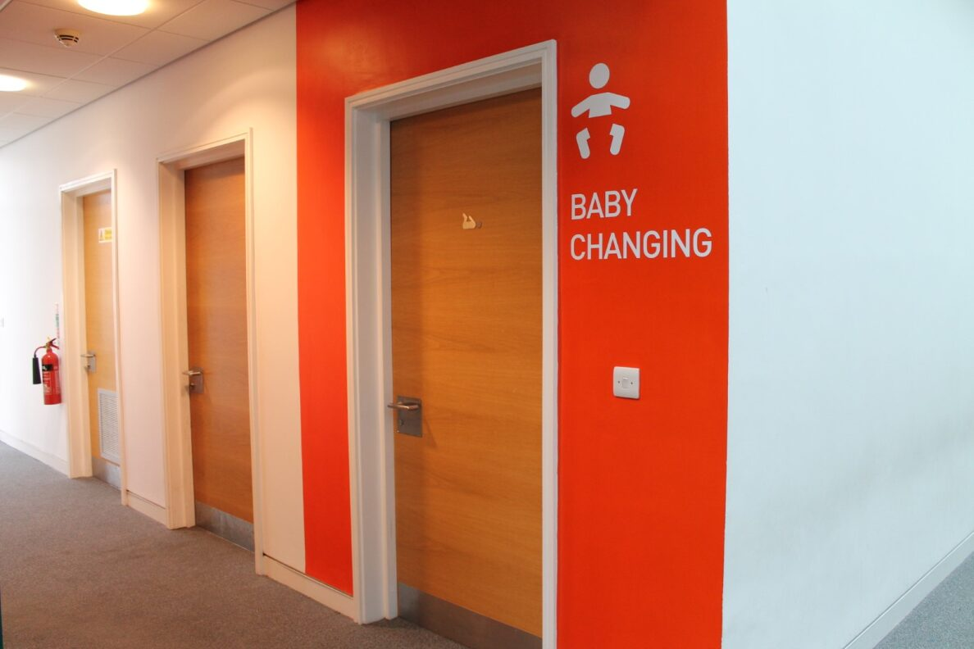
Signage and door into baby change facility

Getting around outside

Fire Assembly Point
- From the main entrance to this area, there is level access. There is a permanent ramp. The route is 2300mm wide, or more. The entrance is 1160mm wide.
- The fire assembly point is a small, paved area outside the main building entrance next to the car park.
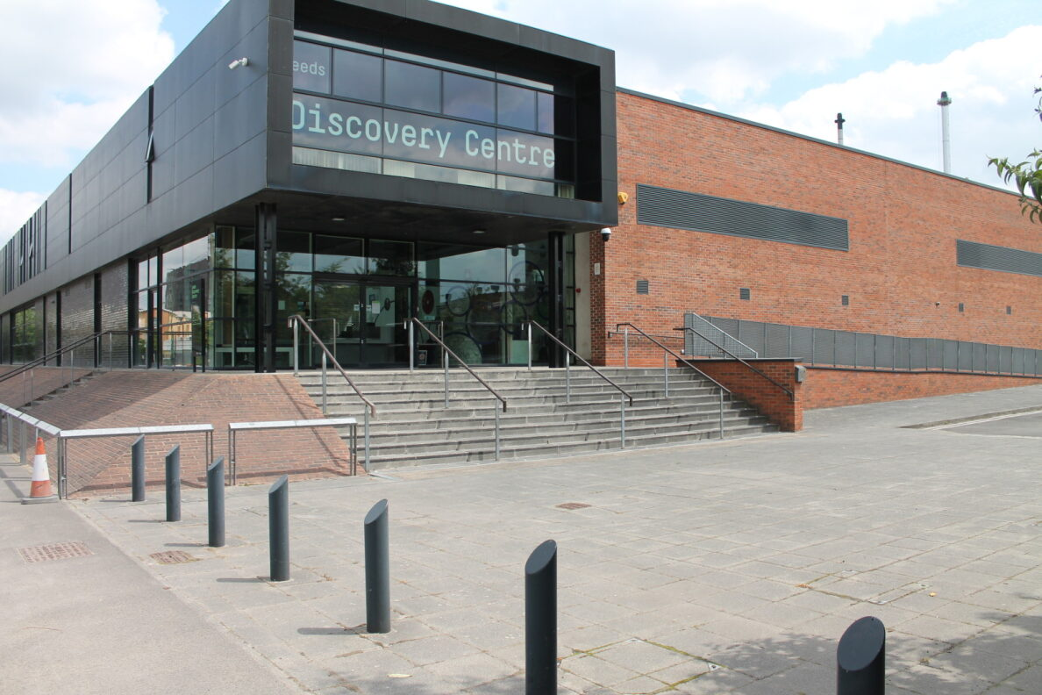
Image of the paved area outside the main entrance, which is the fire assembly point for the building.

Customer care support

Accessibility equipment
- We provide wheelchairs. Wheelchairs are free.
- We have a hearing loop in The Reception area and Discovery Space.
- We have an SEND (Special Educational Needs and Disabilities) equipment box, care of the Learning and Access Officer, containing ear defenders, image prompt cards and wind-up torches.
- The nearest toilet area for assistance dogs is located within Leeds Dock. A water bowl can be provided, please ask at reception if water is required for your dog.
- We have an area to charge mobility scooters and battery powered wheelchairs.
- Mobility scooters can be charged at the Reception desk.
- You can hire mobility equipment from Mobility Matters Leeds by calling 0113 216 1000.

Emergency evacuation procedures
- We have emergency evacuation procedures for disabled visitors.
- The fire alarm has flashing lights.
- The fire alarm is tested at 8.45am on Mondays.
- Fire exits are located at either end of the downstairs corridor, and at the bottom of the stairs. There is an evacuation chair located at the top of each first-floor staircase. In case of an evacuation, all visitors will be shown to the nearest exit by a member of the team. The emergency assembly point is located in the car park unless instructed otherwise by a team member. Not all fire exits have an accessible ramp down to street level.

Customer care support
- Some staff have disability awareness training.
- Some staff have received basic Makaton training.
- We have other services for people with accessibility requirements.
- Community groups with varying accessibility needs are welcome. We can tailor workshops and tours to many different groups depending on their requirements. These workshops are held in the Discovery Space or the First Floor Meeting Room. Our venues can be booked commercially.

Guide last updated: 4th April 2024

