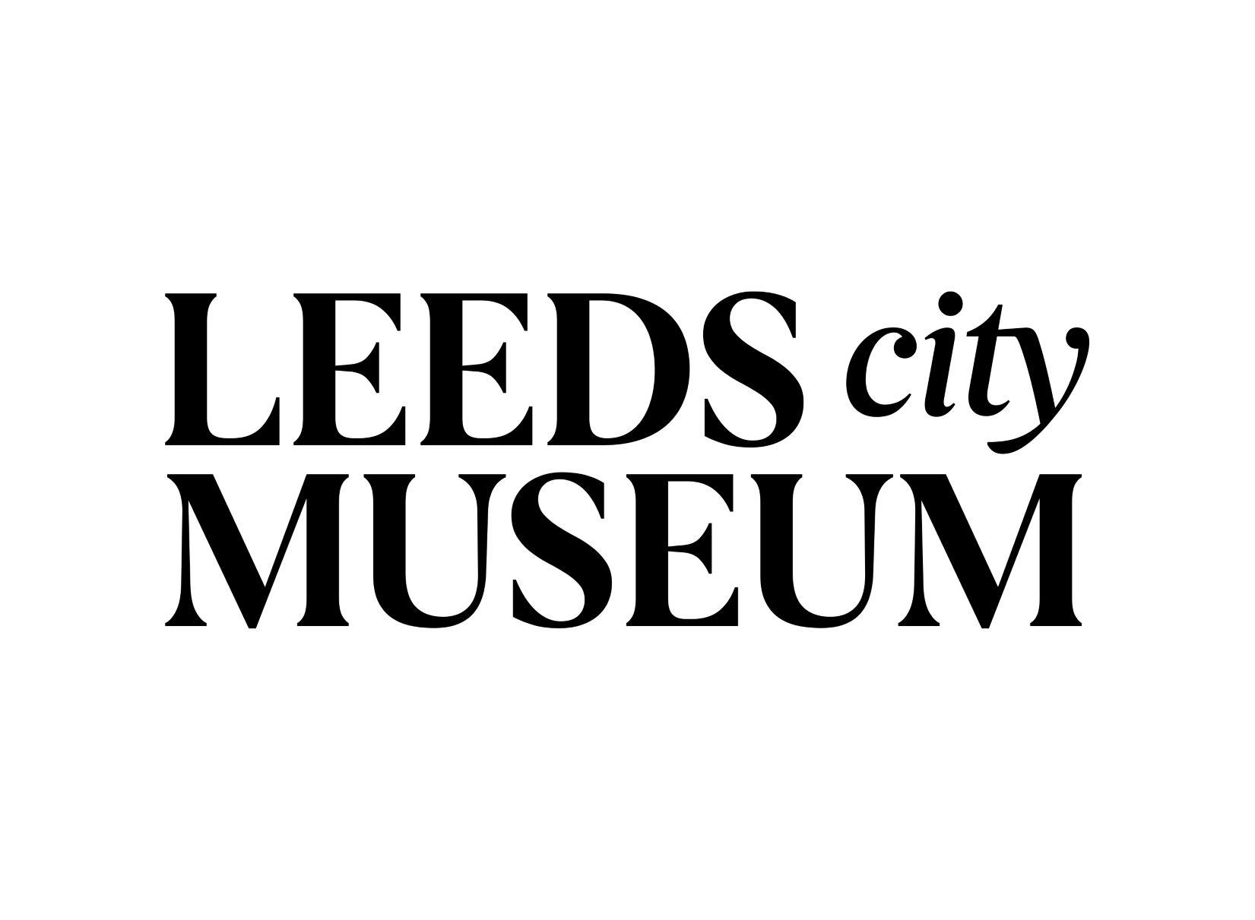

Accessibility Guide for Leeds City Museum
city.museum@leeds.gov.uk, 0113 3785001, www.museumsandgalleries.leeds.gov.uk/leeds-city-museum
Contact for accessibility enquiries: Natalie Haigh, Learning and Access Officer
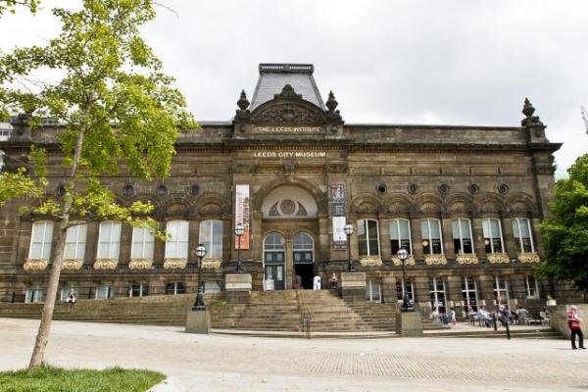

Welcome
Leeds City Museum is a free venue in the heart of Leeds. The museum houses archaeology, social history, world cultures, natural science and contemporary objects.
The historic building is located on Millennium Square and there is level access to all floors. We aim to provide a friendly, accessible environment for all our visitors and the widest possible access to our building, exhibitions and collections.
Trigger Warning: Some of the displays may contain content that people find an emotional trigger. We use signage to warn of sensitive content.
Please get in touch if you require any further information to help you plan your visit.

At a Glance

Level Access
- The main entrance has level access with a ramp. The ramp is permanent.
- There is level access from the main entrance to:
  - Dining Table
  - Life on Earth gallery
  - Voices of Asia gallery
  - Collectors Cabinet gallery
  - Brodrick Hall
  - Leeds Story gallery
  - Ancient Worlds gallery
  - Special Exhibition gallery
  - Thoresby Room - Conference and Events
  - Denny Room - Conference and Events
  - Learning Centre
  - Changing Places toilet, Floor 3
  - Accessible Toilet, Lower Ground
  - Museum Shop

Hearing
- We have a hearing loop in Denny and Thoresby conference/event rooms, and Ancient Worlds gallery. A portable hearing loop is available for some other areas.
- Some staff have BSL and disability awareness training.

Visual
- Glass doors have contrast markings.
- Some parts of the venue have low lighting.
- We have display information in audio, BSL and large print.
- We have information in audio, BSL, large print and other.

General
- There is at least 1 public toilet for disabled visitors.At least one toilet is a Changing Places toilet.
- Some staff have disability awareness training.

Getting here
Cookridge Street
Leeds
LS2 8BH

Travel by public transport
- You can get to Leeds City Museum by bus and train.
- The nearest bus stops are on Woodhouse Lane, Great George Street, Calverley Street or the Headrow. The bus stop is 0.1 miles / 0.2 km from Leeds City Museum.
- The nearest train station is Leeds. The train station is 0.5 miles / 0.8 km from Leeds City Museum.
- The route from the train station to the museum is a gradual incline.

Parking
- There is a drop-off point at the main entrance. The drop-off point has a dropped kerb.
- The drop off point nearest to the access ramp is where Portland Gate meets Cookridge Street. There is drop-curb access to the museum via Millennium Square. An alternative drop off point is where Cookridge Street meets Rossington Street.
There isn't a car park. The nearest accessible on-street parking bays are located where Cookridge Street meets Rossington Street.
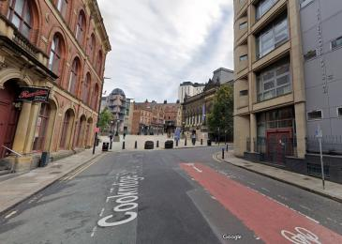
View from Cookridge Street, showing drop curb access to museum via Millennium Square

Arrival

Path to main entrance
- From the street to the main entrance, there is level access.
- There is a permanent ramp.
- The path is 1410mm wide, or more.
- The path is sloped.

Main entrance
- The main entrance has level access.
- There is a permanent ramp.
- The door is 1440mm wide.
- The door has a push button to open it.
- The main entrance has 2 doors. There is a push button located between the 2 doors. This button opens the doors to the left.
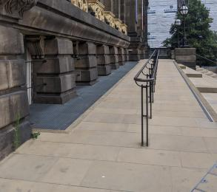
Ramp to Leeds City Museum main entrance, with handrail
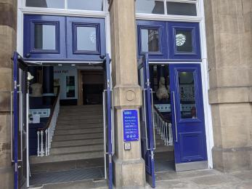
Main entrance. The push button between the 2 doors opens the doors to the left.

Getting around inside

Visual Impairment - General Information
- We have contrast markings on all glass doors.
- Some parts of the venue have low lighting.
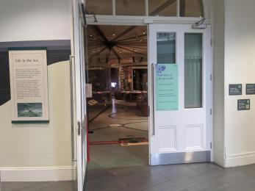
Looking into the Life on Earth Gallery from the corridor. Many gallery spaces have dim lighting to protect objects.

Lift
- We have 1 lift.
- You can get a lift to all floors.

Lift to all floors
- The lift door is 1100mm wide.
- The lift is 1680mm wide. The lift is 1500mm deep.
- The lift says the floor number at each floor.
- The lift buttons have raised numbers or letters.
- The lift shows the floor number, at each floor.
- Inside the main entrance, turn left to find the lift. The lift has 2 different doors, so it might be that you exit the lift from the door behind you on some floors. The main entrance is located on the Ground floor.
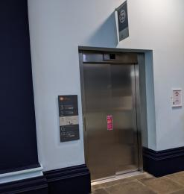
Visitor lift

Things to See and Do
- We have performances with: British Sign Language interpreted, relaxed and touch tour.
- We have display information in: audio, BSL and large print.
- We have a designated quiet space.

Life on Earth gallery
- From the main entrance to this area, there is level access. There is a lift.
- From the lift to this area, the route is 2080mm wide, or more. The door is 2080mm wide.
- Some display information is low, for wheelchair users. There are seats.
- The entrance door to Life on Earth is 1040mm with one door propped open. The other door opens up to make a wider entrance of 2080mm.
Some areas of this gallery are dimly lit to prevent light damage. Please ask if you want to borrow a torch during your visit.
QR codes are available in this gallery for visitors to view more information on their phone/device.
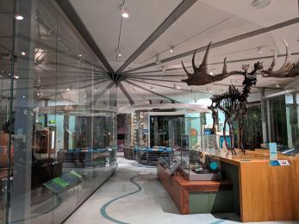
Inside the Life on Earth gallery
Entrance to Life on Earth
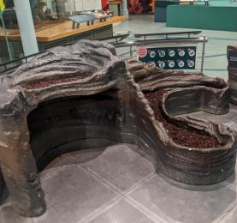
The fossil dig has space underneath for a wheelchair. The height of this is 600mm.

Voices of Asia gallery
- From the main entrance to this area, there is level access. There is a permanent ramp. There is a lift.
- From the lift to this area, the route is 1250mm wide, or more. The door is 2390mm wide.
- Some display information is low, for wheelchair users. There are seats.
- Some videos have subtitles.
- There is a touch alcove and some buttons to listen to audio descriptions of some of the objects in this gallery
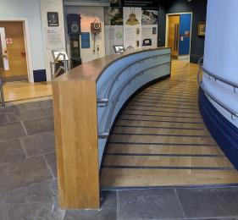
Ramp to Voices of Asia gallery
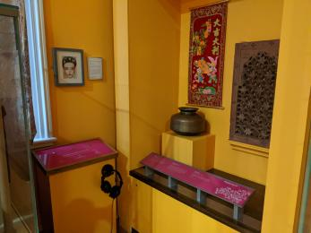
Touch alcove and object audio descriptions

Collectors Cabinet gallery
- From the main entrance to this area, there is level access. There is a lift.
- From the lift to this area, the route is 1500mm wide, or more. The door is 2390mm wide.
- Some display information is low, for wheelchair users. There are seats.
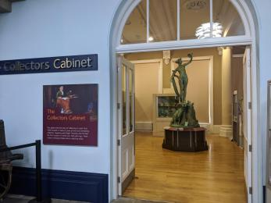
Entrance to Collectors Cabinet gallery
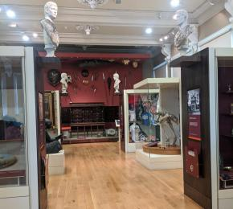
Collectors Cabinet gallery

Brodrick Hall
- From the main entrance to this area, there is level access. There is a lift.
- From the lift to this area, the route is 1100mm wide, or more. The door is 1900mm wide.
- Some display information is low, for wheelchair users. There are seats.
- There is a hearing loop.
- Some videos have subtitles.
- The Brodrick Hall is sometimes closed for private events. This is a large space with a lot of circulation area. Sometimes the route may be narrower if there is extra event furniture in the space. There is a large map of Leeds on the floor in this space. There is a hearing loop which can be requested for private hire events.
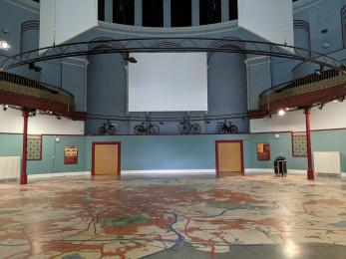
Brodrick Hall event space

Leeds Story gallery
- From the main entrance to this area, there is level access. There is a lift.
- From the lift to this area, the route is 1500mm wide, or more. The door is 1500mm wide.
- Some display information is low, for wheelchair users. There are seats.
- Videos have subtitles.
- Some of the play areas within this gallery have narrower entrances. The doorway to the roundhouse is 2150mm wide, and 1170mm high. The toddler town play area has smaller children's doorways which are 550mm wide or wider, and some of the crawl through areas have lower height at 690mm high.
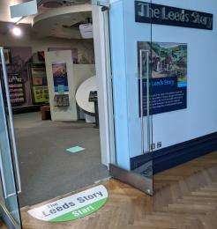
Entrance to Leeds Story gallery
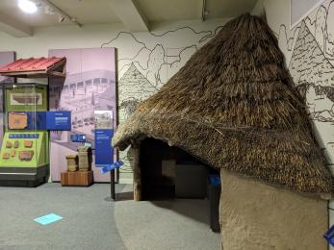
Roundhouse interactive area

Ancient Worlds gallery
- From the main entrance to this area, there is level access. There is a lift.
- From the lift to this area, the route is 1750mm wide, or more. The door is 1660mm wide.
- Some display information is low, for wheelchair users. There are seats.
- There is a hearing loop.
- Some videos have subtitles.
- The yellow arrows on the floor show the area to view the mummified person. This area is dimly lit.
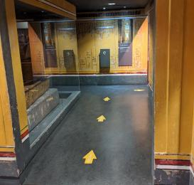
Ancient Worlds gallery

Special Exhibition gallery
- From the main entrance to this area, there is level access. There is a lift.
- From the lift to this area, the route is 1800mm wide, or more. The door is 1900mm wide.
- Some display information is low, for wheelchair users. There are seats.
- Videos have subtitles.
- The route and layout in the Special Exhibition gallery changes per exhibition. We always aim for the narrowest part of the route to be 1100mm. If you require assistance in this gallery, please ask a Visitor Assistant.
QR codes are available in this gallery for visitors to view more information on their phone/device.
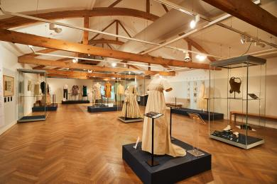
Special Exhibition gallery - layout varies

Thoresby Room - Conference and Events
- From the main entrance to this area, there is level access. There is a lift.
- From the lift to this area, the route is 2200mm wide, or more. The door is 1700mm wide.
- Some display information is low, for wheelchair users. There are seats.
- There is a hearing loop.
- Some videos have subtitles.
- The layout of this room changes depending on the event. For talks, we lay out the room with space for wheelchairs. The door to this room is 1770mm when double doors are open, or 850mm when single door is open.
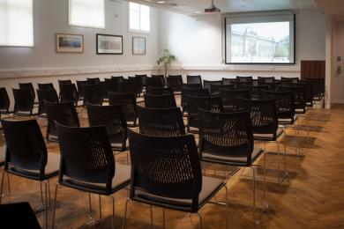
Thoresby Room

Denny Room - Conference and Events
- From the main entrance to this area, there is level access. There is a lift.
- From the lift to this area, the route is 2200mm wide, or more. The door is 1550mm wide.
- Some display information is low, for wheelchair users. There are seats.
- There is a hearing loop.
- Some videos have subtitles.
- The layout of this room changes depending on the event. For talks, we lay out the room with space for wheelchairs. The door to this room is 1550mm when double doors are open, or 760mm when single door is open.
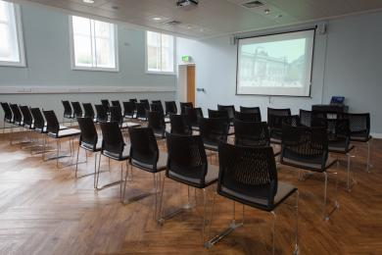
Denny Room

Learning Centre
- From the main entrance to this area, there is level access. There is a permanent ramp. There is a lift.
- From the lift to this area, the route is 1250mm wide, or more. The door is 1500mm wide.
- Some display information is low, for wheelchair users. There are seats.
- Some videos have subtitles.
- This is a classroom area for craft activities. Due to the table and chair layout, sometimes there won't be an unobstructed route at least 800mm wide to get around the whole space. There is 800mm route from the doorway to the activity tables. The height of some of our activity tables can be adjusted, and we have chair and bench seating available.
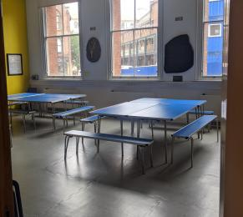
Learning Centre

Public toilet

Changing Places toilet, Floor 3
- There is a public toilet for disabled visitors.
- The toilet is a Changing Places toilet.
- You need a RADAR key to open the public toilet.
- From the main entrance to the public toilet, there is level access. There is a lift.
- From the lift to the public toilet, the route is 1770mm wide, or more.
- The toilet door is 1060mm wide.
- The direction of transfer onto the toilet is to the left and right.
- There is 700mm at the side of the toilet. There is 1420mm in front of the toilet. The toilet seat is 460mm high. The toilets have handrails.
- You can request a radar key from our front of house staff, should you require one.
There is another public toilet on this floor.
There is an emergency pull cord.
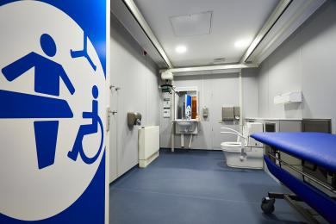
The Changing Places toilet at Leeds City Museum

Public toilet

Accessible Toilet, Lower Ground
- There is a public toilet for disabled visitors.
- From the main entrance to the public toilet, there is level access. There is a lift.
- From the lift to the public toilet, the route is 1200mm wide, or more.
- The toilet door is 850mm wide.
- The direction of transfer onto the toilet is to the right.
- There is 600mm at the side of the toilet. There is 900mm in front of the toilet. The toilet seat is 480mm high. The toilets have handrails.
- There are 2 accessible toilets like this on the Lower Ground floor. There is a baby changing table within these also. We also have accessible toilets on floors 1 and 2, and the Changing Places toilet on floor 3.
There is an emergency pull cord in the accessible toilets.
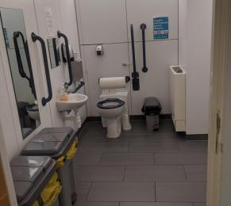
Accessible Toilet, Lower Ground
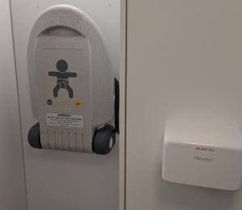
Baby change facilities

Shop

Museum Shop
- From the main entrance to the shop, there is level access. There is a lift.
- From the lift to the shop, the route is 1500mm wide, or more. The door is 2150mm wide.
- The route through the shop is 800mm wide, or more.
- There is a low level counter which is 760mm high.
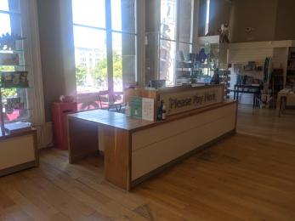
Museum shop

Place to eat and drink

Herbarium Cafe
- From the main entrance to the dining area, there is level access. There is a lift. From the lift to dining area, the route is 1300mm wide, or more. The door is 1500mm wide.
- To get to a table, there are no steps.
- If you need table service, staff can help you.
- The route through the dining area is 800mm wide, or more.
- There is no background music.
- We cater for sugar free (diabetic), vegetarian, gluten free (celiacs), lactose free (dairy free), nut free, low fat, high fibre, vegan and halal specific diets.
- There is an entrance to the cafe from Millennium Square, which goes straight into the cafe, without needing to use a lift. The cafe has 3 doorways to enter from Millennium Square. The left doorway has a push button to open the door. Occasionally our cafe is closed so please check the website or social media for information.
Specific diets: For menu items, you can request ingredients, allergen and calorie information at the cafe.
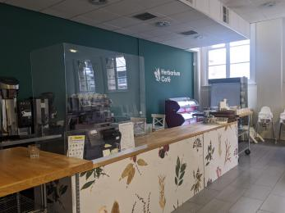
Herbarium Cafe

Customer care support

Accessibility equipment
- We provide wheelchairs. Wheelchairs are free.
- We have a hearing loop in Denny and Thoresby conference/event rooms, and Ancient Worlds gallery. A portable hearing loop is available for some other areas.
- Torches, ear/sound defenders, touch tours with museum objects (if requested in advance).
- The nearest toilet area for assistance dogs is located next to the cafe. There are larger areas of grass on Cookridge Street, 0.1 miles from the venue.
- This might be possible, please get in touch to discuss.

Emergency evacuation procedures
- We have emergency evacuation procedures for disabled visitors.
- There are refuse points around the building, and staff are trained in evac chair use, should the lift be unavailable in a fire alarm situation. In the emergency evacuation procedure, front of house staff check each floor of the building.

Customer care support
- Some staff have disability awareness training.
- Some staff have BSL training.
- We have information in audio, BSL, large print .
- Some of the galleries have QR codes so visitors can view information on their phones
- We have other services for people with accessibility requirements.
- Please get in touch if you would like to enquire about our front of house assisting/guiding around the building. We can also provide touch tours, object handling in gallery spaces, or short talks/descriptions about key objects.

Guide last updated: February 2024

