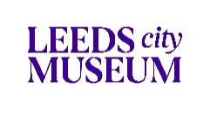

The Leeds City Museum Story

Preparing for your visit with new safety measures

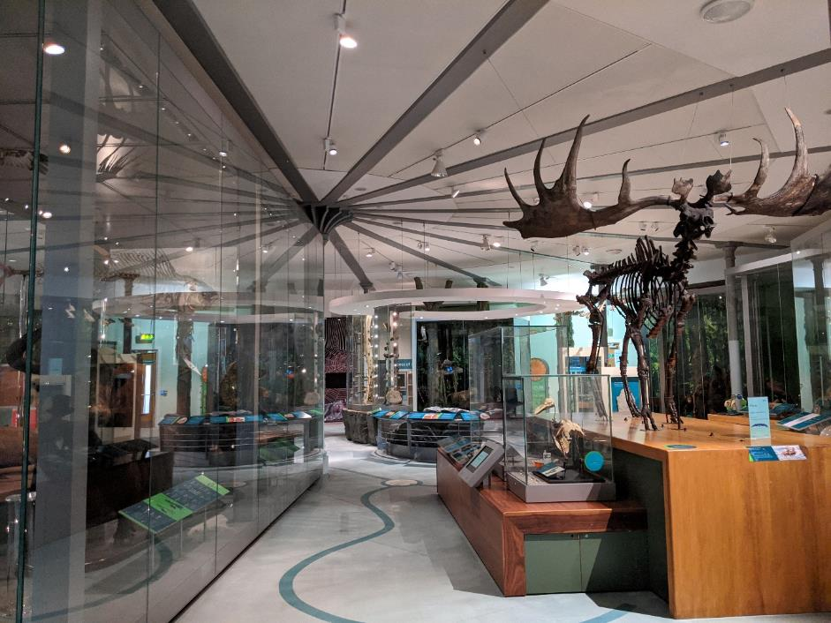

Before I come to the Museum

I might bring a toy with me to the Museum.

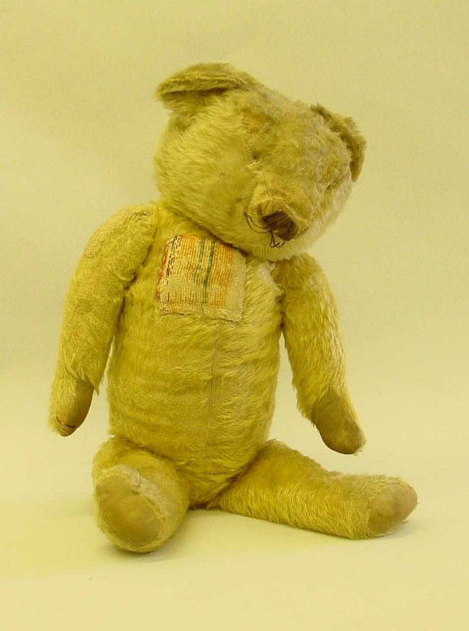

I might bring a favourite book to read at the Museum.

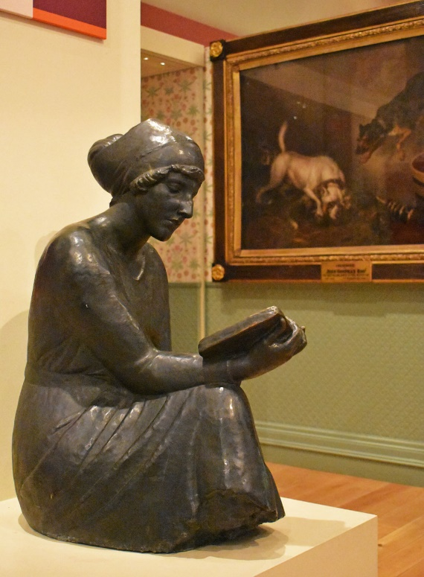

I don’t need a ticket to visit the Museum.

I might download a Museum floor map before I come: Leeds City Museum Floor Map PDF 250KB

Things to help me at Leeds City Museum

People who work at the Museum are called Visitor Assistants. I can ask them if I need help.

They wear white and black uniforms.

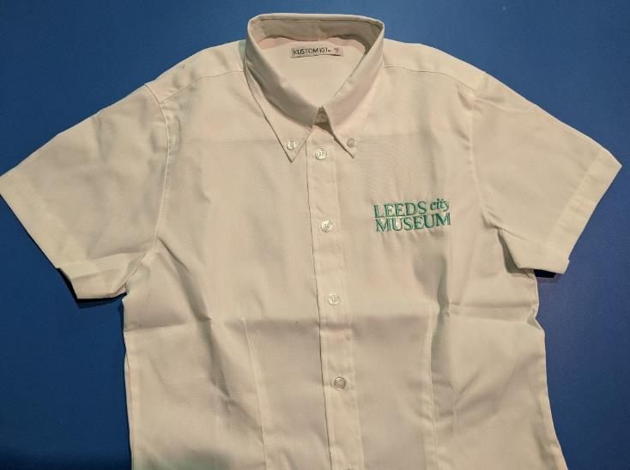

If I need a quiet space during my visit, I can follow the sign or ask staff how to find a quiet room.

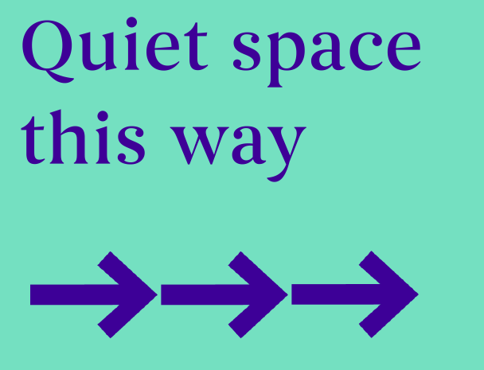

When I get to the Museum

I can use the ramp or steps to get to the entrance of the Museum.

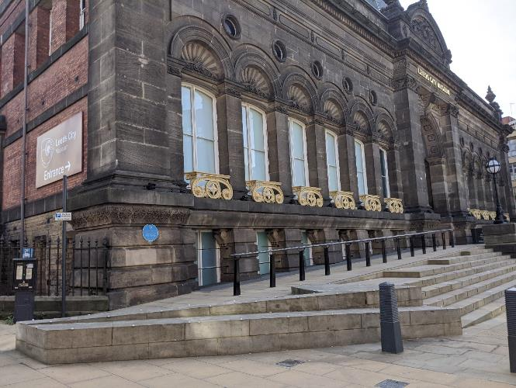

There might be a queue of people waiting on the ramp to the Museum.

If I find queuing difficult, I can ask a Visitor Assistant at the entrance for help.

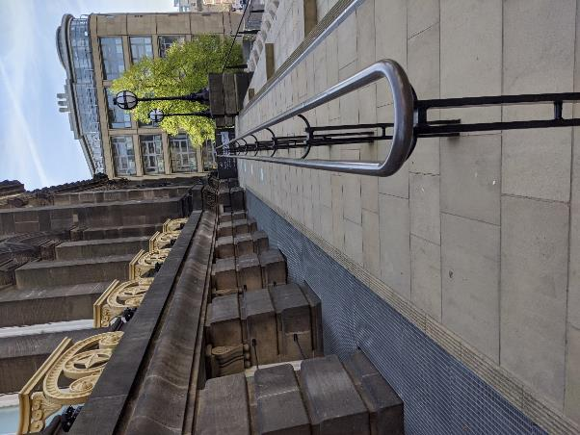

Inside the Museum

When I enter the Museum, a Visitor Assistant will greet me. They will tell me about the Museum and help me know where to go next.

Welcome

We / I can choose which parts of the Museum to visit and how long to stay for.

I can follow the arrows and keep a safe social distance from other visitors.

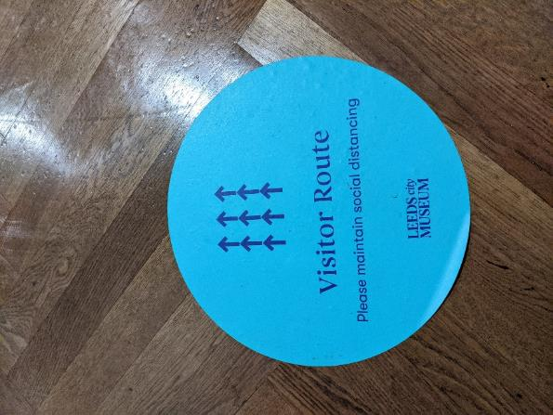

There are galleries on four different levels of the Museum building.

I can use the stairs or lift.

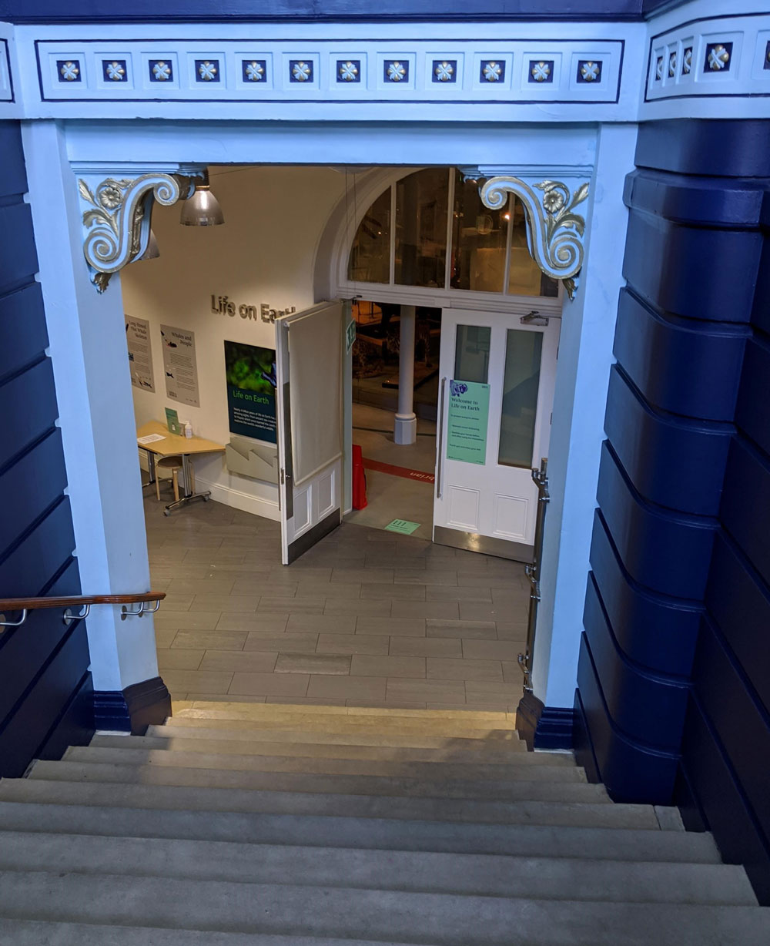

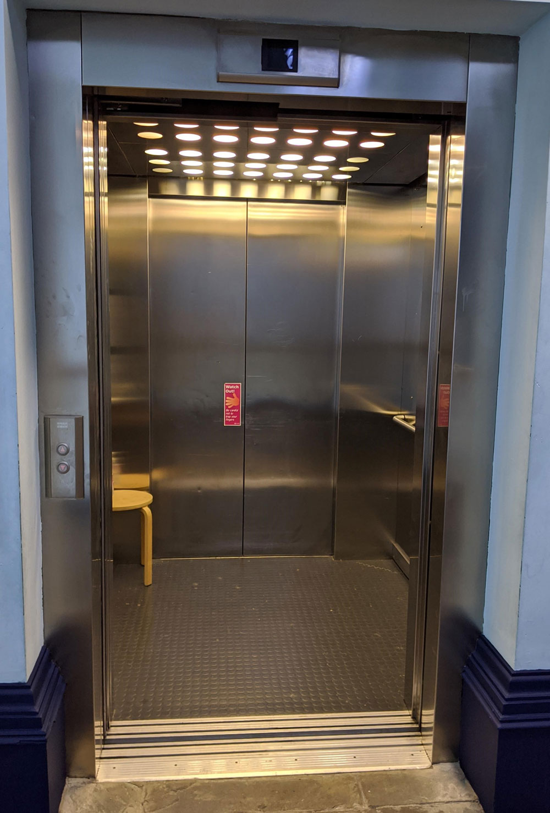
Keeping safe

The Museum is cleaned regularly.

The Museum will be a bit emptier than usual to help people keep their distance.

I will see some adults and older children wearing a face covering inside the Museum. I might wear a face covering too, if I am old enough.

I can use the hand sanitizer in the Museum, or bring my own.

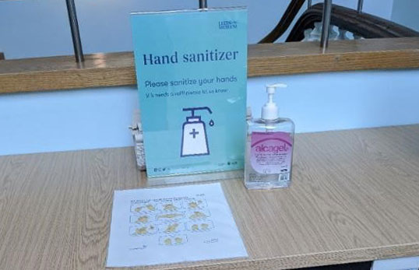

Noises in the Museum

Here are some sounds I might hear:

- Hand-dryers near to the Lower Ground floor toilets – these can be quite loud
- Animal sound effects and music in the galleries

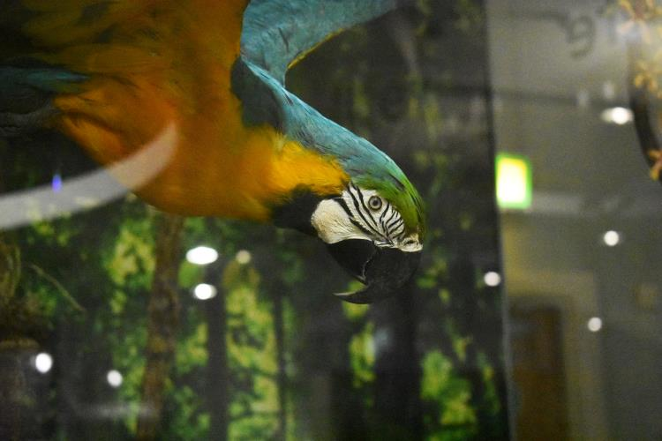

Lighting in the Museum

Some rooms are dimly lit. This is to protect objects from light damage.

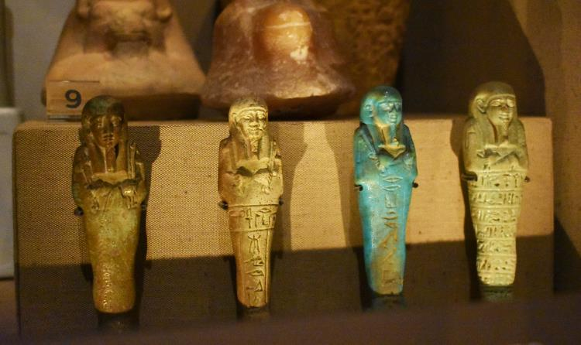

Ancient Egyptian Mummy

I can choose whether I want to look at the Ancient Egyptian mummy. This is in a small area at the back of the Ancient Worlds gallery.

Facilities

Some of the Museum toilets are available.

There are toilets, accessible toilets and baby change facilities on the Lower Ground floor. The Changing Places toilet is on the third floor.

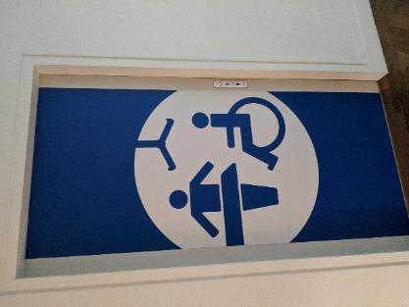

There is a café on the lower ground floor of the Museum. At present, there is no picnic space available.

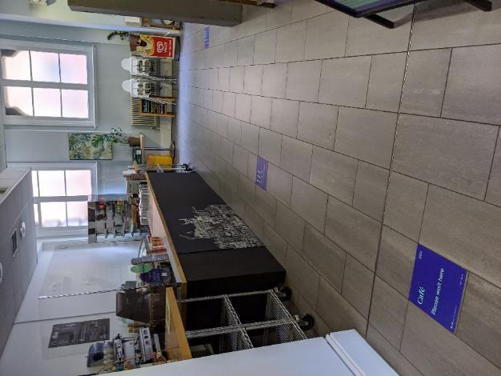

There are wipe-clean seats around the museum

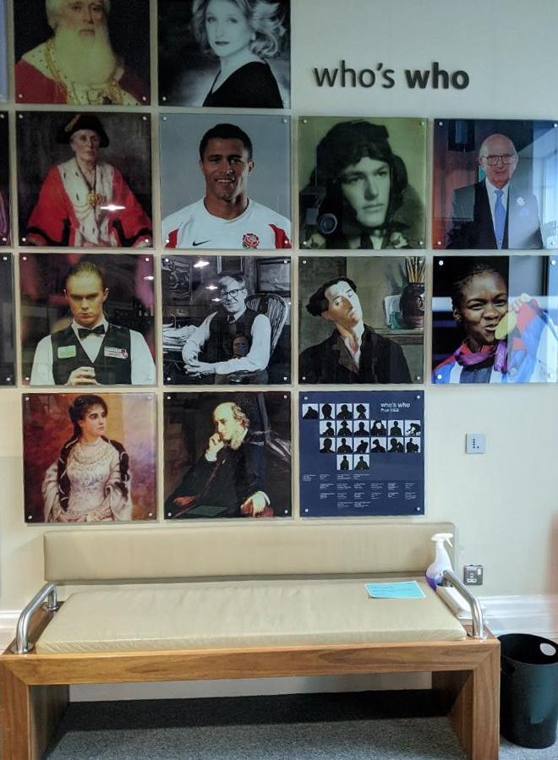

The Museum does not have a car park. There are on-street accessible parking bays nearby, on Rossington Street.

More information about Museum access can be found on our website: museumsandgalleries.leeds.gov.uk/leeds-city-museum/visit-leeds-city-museum/#access

