


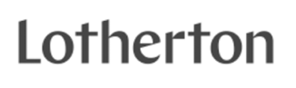
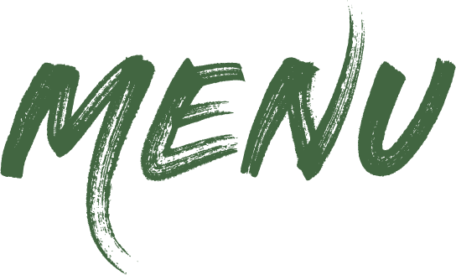



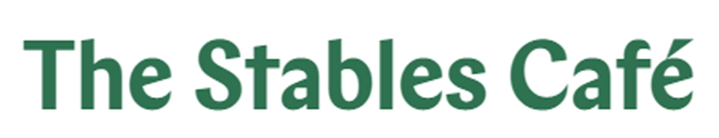
Stables Breakfast 999kcal
Two fried eggs, two slices of rindless back bacon, two rare breed sausages, baked beans, mushrooms, half a tomato, two slices of wholemeal toast and two butter portions
Vegetarian Breakfast (V) 718kcal 
Two fried eggs, two vegan sausages, baked beans, mushrooms, one tomato, two slices of wholemeal toast and two butter portions
Stables Breakfast – The Smaller One 566kcal
One fried egg, one slice of bacon, one sausage, baked beans, mushrooms, half a tomato, one slice of wholemeal toast and a butter portion

Scrambled Egg on Toast (V) 409kcal
Three eggs on two slices of wholemeal toast

£9.50
£8.75

£6.75
£5.25
Served until 11:30

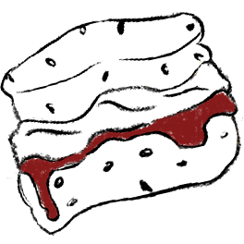





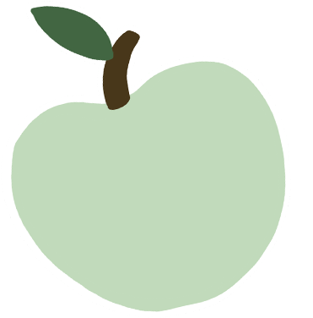
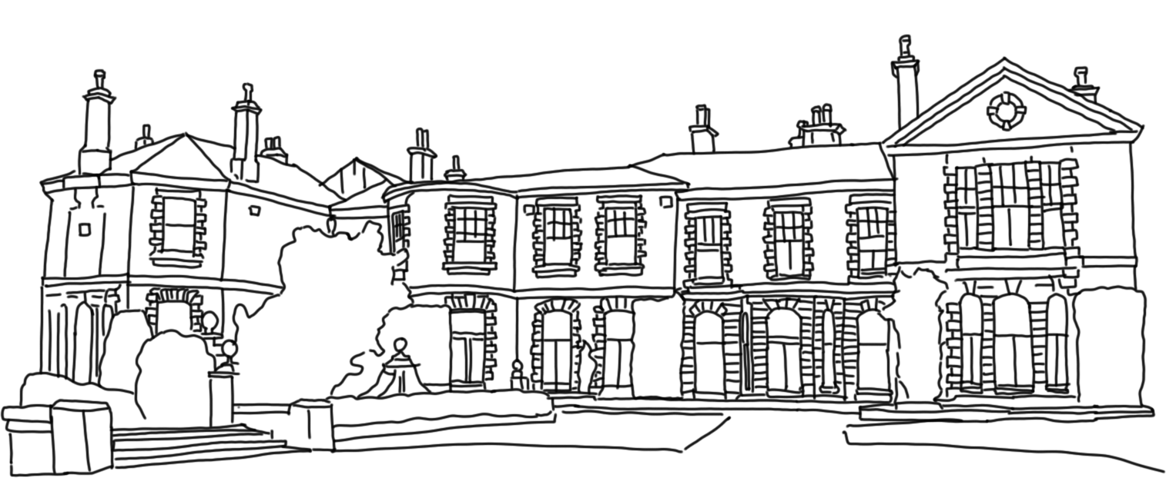

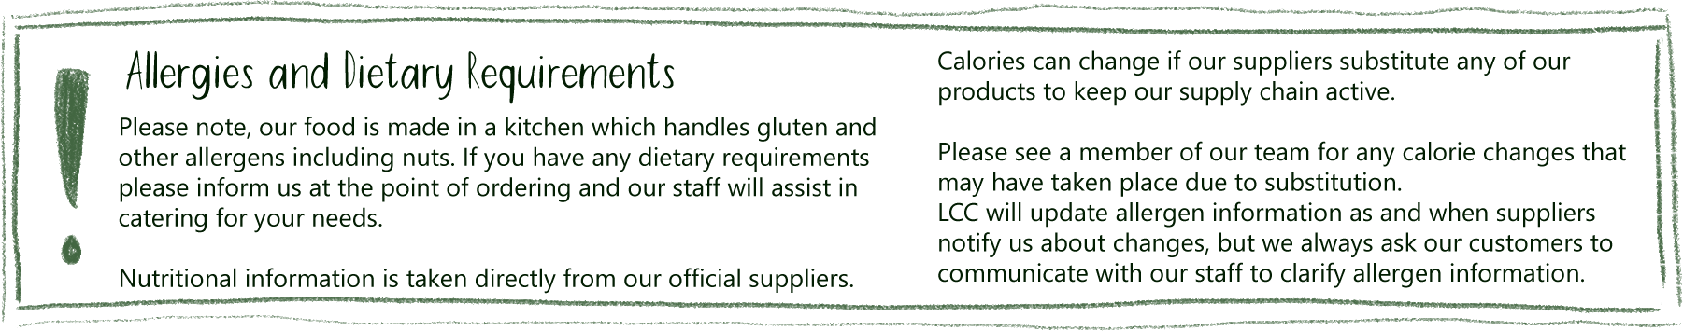
£6.85
£4.50
£3.45
£2.75
Breakfast Sandwiches –
all served in a fresh bap, a choice of...
Three rashers of rindless back bacon 437kcal
Three rare breed sausages 571kcal
Three vegan sausages (V, VG) 304kcal

Beans on Toast (VG) 417kcal
Two slices of wholemeal toast with a portion of beans

Toasted Currant Teacake (V) 423kcal with three butter portions

Two Slices of Wholemeal Toast (V) 278kcal with two butter portions
Served all day
Flapjack (V) from 410kcal £4.25
Mrs Crimbles (V,NG) £4.00
from 251kcal

Homemade Cookies (V) £3.25 212kcal

Slice of Cake £4.60
A varied selection of cakes

Homemade Traybake £4.10
A choice of fresh sweet treats
from our counter display
Check our counter for the full selection of sweet treats
£3.50
£2.80
£2.30
£2.20
£1.95
£2.30
£3.65
£5.00

Heritage Apple Juice 250ml from 133kcal
Vintage Craft Cider 500ml, ABV 6.2%, 3 units,
from 265kcal
Most of our food and drinks can be available to takeaway
Homemade Scone (V) £4.10 with two butter portions 515kcal

Scone, Jam & Cream (V) £5.95
with jam and clotted cream pot 631Kcal
Mug of Tea (V) 0kcal £2.55

Mug of Flavoured Tea (V) 0kcal £2.80
Americano (VG) 4kcal £3.55
Cappuccino (V) 69kcal £4.20
Latte (V) 79kcal £4.20

Espresso (VG) 5kcal £3.10
Flat White (V) 34kcal £4.20
Mocha (V) 198kcal £4.75
Babyccino (V) 69kcal £1.65
Hot Chocolate (V) 192kal £4.60
Deluxe Hot Chocolate 292kcal £5.95
with Cream and Marshmallows
Syrup shot (VG) from 48kcal £1.40
*Semi-Skimmed Milk (V) 5kcal
+ 50p Oat Milk (VG) 6kcal,
+ 50p Soya Milk (VG) 4kcal
*Decaffeinated coffee and
tea available
Made from Lotherton apples!
V – Vegetarian VG – Vegan
NG – Non-Gluten
Fentimans Soft Drinks 275ml from 107kcal
Canned Soft Drinks 330ml from 1kcal
Simply Fruity 330ml from 11kcal
Harrogate Spa Still Water 500ml 0kcal
Milkshake 200ml 46kcal

Flavoured Water 500ml from 1kcal

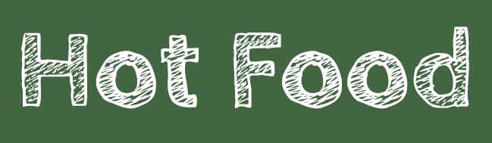







Served hot or cold
Pork Sausage Roll 321kcal
Cheese and Onion Pasty (V) 384kcal
Beef and Vegetable Pasty 439kcal
Pork Pie 580kcal
Vegan Roll (VG) 193kcal
£3.25
£4.25
£4.25
£5.25
£3.25



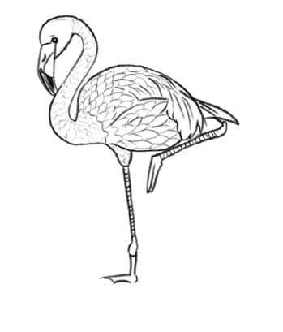



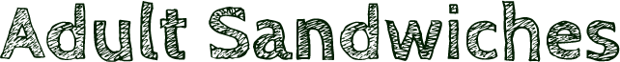




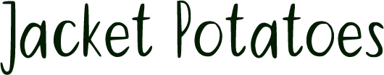
Served in a fresh bap with salad garnish and French dressing

Gammon Ham and Wholegrain Mustard 218kcal
Tuna Mayonnaise and Cucumber 465kcal
Cheddar Cheese and Caramelised Onion (V) 546kcal
(Vegan cheese available on request 459kcal)
£4.15

£5.60

£6.95
Children’s Lunch Box from 395kcal
See chiller for details

Children’s Breakfast (Served until 11:30) 553kcal
One fried egg, one slice of bacon, one sausage,
baked beans, a slice of wholemeal toast and a
butter portion

Toast (V) 139kcal
One slice of wholemeal toast with a butter portion

Beans on Toast (VG) 208kcal
One slice of wholemeal toast covered in baked beans
Add Cheese (V) 374kcal

Tomato Pasta With Side Salad (VG) 269kcal

Half a Jacket Potato With Side Salad 181kcal

Choice of fillings: Cheese (V,NG) 166kcal
Tuna Mayo (NG) 157kcal Baked Beans (VG, NG) 57kcal

Yorkshire Pudding and Gravy (V) 111kcal
4” Yorkshire pudding served with gravy

Yorkshire Pudding, Sausage, Mashed
Potato and Gravy 438kcal
4” Yorkshire pudding served with one sausage, mashed
potato and gravy
£5.25
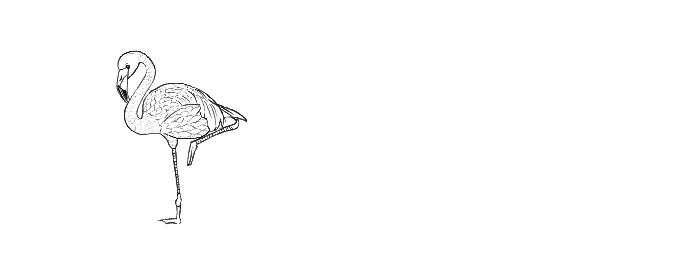£1.55

£3.45
£4.10
£4.15

1 filling - £4.95
2 fillings - £5.55
Homemade Three Bean Chilli  (VG) 586kcal
Homemade three bean chilli served with white boiled rice and lightly salted tortilla chips

Pork, Gravy and Apple Sauce Sandwich 448kcal Hot slices of pork cooked in gravy and topped with apple sauce in a fresh bap. Served with a salad garnish and French dressing

Soup of the Day (V) from 360kcal
Served with a bread roll and a butter portion

Pork Pie, Mushy Peas and Mint Sauce 742kcal
Locally sourced pork pie, topped with mushy peas and
mint sauce

Yorkshire Pudding and Gravy (V) 309kcal
Giant Yorkshire pudding served with gravy

Yorkshire Pudding, Sausage, Mashed
Potato and Gravy 680kcal
Giant Yorkshire pudding served with two sausages, a portion of mashed potato and gravy

1 filling - £8.45 2 fillings - £9.25
We kindly ask that only food purchased in the café is to be consumed on our tables.
Low Carbon

Medium Carbon

High Carbon
V – Vegetarian VG – Vegan NG – Non-Gluten
£9.25

£8.45

£5.95
£7.75

£6.25

£9.25
See the chalkboard for seasonal specials!

Some items on our menu can be adjusted to meet dietary requirements.

Gluten free bread and vegan cheese are available please ask at the time of ordering.

£6.75
Choice of fillings:
Cheese (V,NG) 345kcal. Tuna Mayo (NG) 314kcal
Beans (VG,NG) 120kcal Vegan Cheese (VG,NG) 199kcal

Beans (V,VE,GF) 120kcal

Served with a salad garnish and French dressing

Ham and Cheese 347kcal
Tuna and Cheese 610kcal
Cheese and Tomato 304kcal
(Vegan cheese available on request 336kcal)

Cheese and Red Onion 304kcal
(Vegan cheese available on request 336kcal)
£7.55
*
Served with a salad garnish and French dressing

