



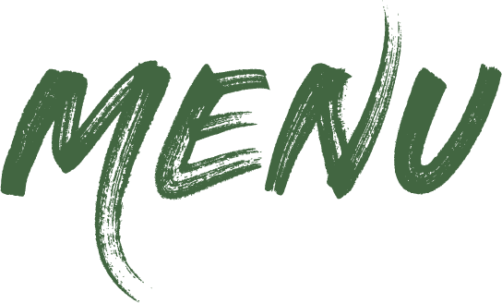



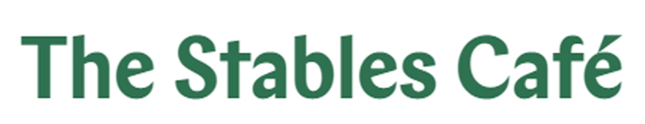
£9.25
£8.25

£6.50
£5.25
Stables Breakfast 1149kcal
Two fried eggs, two slices of back bacon, two sausages, baked beans, mushrooms, half a tomato, two slices of wholemeal toast and two butter portions
Vegetarian Breakfast (V) 718kcal
Two fried eggs, two vegan sausages, baked beans, mushrooms, one tomato, two slices of wholemeal toast and two butter portions
Stables Breakfast – The Smaller One 603kcal
One fried egg, one slice of bacon, one sausage, baked beans, mushrooms, half a tomato, one slice of wholemeal toast and butter
Scrambled Egg on Toast (V) 409kcal
Three eggs on two slices of wholemeal toast
Served until 11:30
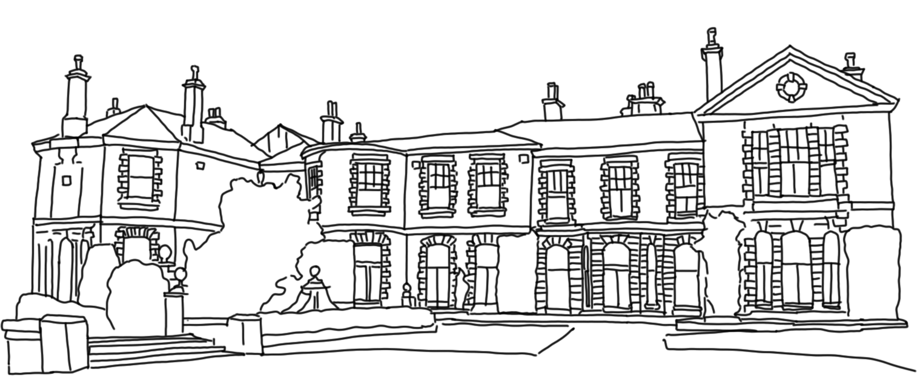






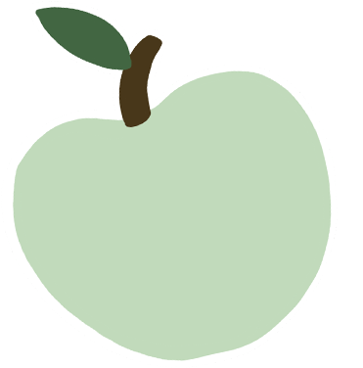

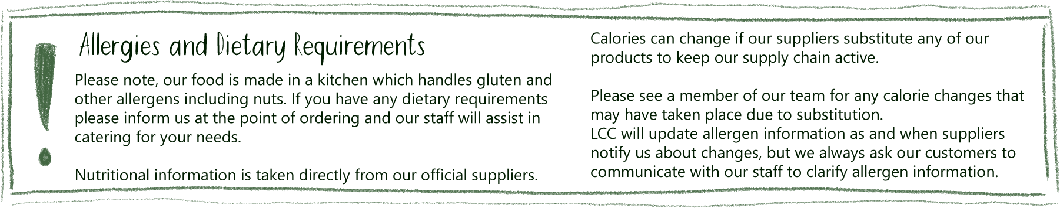

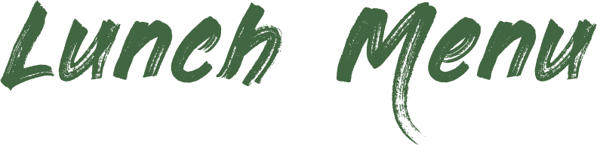



`
Flapjack (V) from 410kcal £4.10

Gluten Free Slices (V,NG)
from 330kcal £4.00

Crispy Buns (V) from 120kcal £2.90

Iced Buns (V) from 296kcal £3.00

Breakfast Sandwiches –
all served in a white breadcake, a choice of...
Three rashers of back bacon 437kcal
Three sausages 685kcal
Three vegan sausages (V, VG) 304kcal
Beans on Toast (VG) 417kcal
Two slices of wholemeal toast with a portion of beans
Toasted Currant Teacake (V) 423kcal
with three butter portions
Two Slices of Wholemeal Toast (V) 278kcal
with two butter portions
Most of our food and drinks can be available to takeaway
Made from Lotherton apples!
V – Vegetarian VG – Vegan
NG – Non-Gluten
£3.50
£2.80
£2.30
£2.20
£1.95
£2.30
£3.40
£5.00

Heritage Apple Juice 250ml from 133kcal
Vintage Craft Cider 500ml, ABV 6.2%, 3 units,
from 265kcal
Most of our food and drinks can be available to takeaway
Check our counter for our current selection of cakes
Homemade Scone (V) £3.95 with two butter portions 515kcal

Scone, Jam & Cream (V) £5.75
with jam and clotted cream pot 631Kcal
Mug of Tea (V) 0kcal £2.55

Mug of Flavoured Tea (V) 0kcal £2.80
Americano (VG) 4kcal £3.55
Cappuccino (V) 69kcal £4.20
Latte (V) 79kcal £4.20

Espresso (VG) 5kcal £3.10
Flat White (V) 34kcal £4.20
Mocha (V) 198kcal £4.75
Babyccino (V) 69kcal £1.65
Hot Chocolate (V) 192kal £4.60
Deluxe Hot Chocolate 292kcal £5.75
with Cream and Marshmallows
Syrup shot (VG) from 48kcal £1.40
*Semi-Skimmed Milk (V) 5kcal
+ 50p Oat Milk (VG) 6kcal,
+ 50p Soya Milk (VG) 4kcal
*Decaffeinated coffee and tea available
£6.85
£4.00
£3.45
£2.75
Made from Lotherton apples!
Fentimans Soft Drinks 275ml from 107kcal
Canned Soft Drinks 330ml from 1kcal
Simply Fruity 330ml from 11kcal
Harrogate Spa Still Water 500ml 0kcal
Milkshake 200ml 46kcal

Flavoured Water 500ml from 1kcal

Slice of Cake – £4.60
A varied selection of cakes
Traybake – £3.90
A choice of fresh sweet treats from our counter display
Served all day
Served hot or cold
£3.25
£4.25
£4.25
£5.25
£3.25
Pork Sausage Roll 321kcal
Cheese and Onion Pasty (V) 384kcal
Beef and Vegetable Pasty 439kcal
Pork Pie 580kcal
Vegan Roll (VG) 193kcal
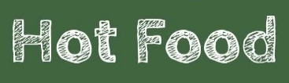





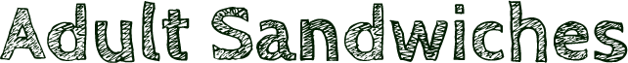




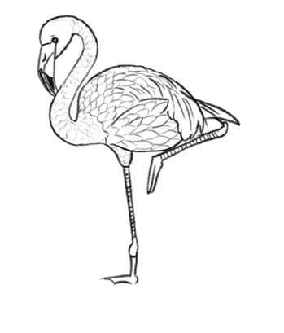


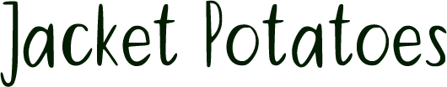
Tuna Platter From 883kcal
Tuna Mayonnaise served with salad, French dressing, celery, grapes, coleslaw, bread roll and butter

Ploughman’s 1394kcal
½ local pork pie, ham, grated cheddar cheese, salad, French dressing, caramelised onion, celery, grapes, coleslaw, bread roll and butter

Vegan Ploughman’s (V, VG) 1089kcal
Vegan roll, vegan grated cheese, salad, French dressing, caramelised onion, celery, grapes, coleslaw, bread roll and vegan spread

£10.75

£4.75
Homemade Three Bean Chilli  (VG) 586kcal
Homemade three bean chilli served with white boiled rice and lightly salted tortilla chips

Cheeseburger 688kcal
Beef burger with cheddar cheese, lettuce, tomato and burger relish in a brioche bun. Served with salad garnish and French dressing

BBQ Bacon Cheeseburger 756kcal
Beef burger, bacon, cheddar cheese, lettuce, tomato, BBQ sauce in a brioche bun. Served with salad garnish and French dressing

Garden Cheeseburger (VG) 601kcal
Vegetable burger, vegan mayonnaise, lettuce, tomato in a brioche bun. Served with salad garnish and French dressing

Soup of the Day (V) 360kcal
Served with a bread roll and butter

£9.25
£7.90

£8.90
£7.90

£5.95

*
Some items on our menu can be adjusted to meet dietary requirements.
Gluten free bread and vegan cheese are available, please ask at the time of ordering.

We kindly ask that only food purchased in the café is to be consumed on our tables.
£6.75
Served in a fresh bap with a salad garnish and French dressing

Gammon Ham and Wholegrain Mustard 218kcal
Tuna Mayonnaise and Cucumber 465kcal
Cheddar Cheese and Caramelised Onion (V) 546kcal
(Vegan cheese available on request 459kcal)
£1.55

£3.45
£4.10
£4.15

1 filling - £4.95 2 fillings - £5.55

Children’s Breakfast (Served until 11:30) 589kcal
One fried egg, one slice of bacon, one sausage,
baked beans, a slice of wholemeal toast and one butter portion

Toast (V) 139kcal
One slice of wholemeal toast with a butter portion
Beans on Toast (VG) 208kcal
One slice of wholemeal toast covered in baked beans
Add Cheese (V) 374kcal
Tomato Pasta With Side Salad (VG) 269kcal
Half a Jacket Potato With Side Salad 181kcal
Choice of fillings: Cheese (V, NG) 166kcal Coleslaw (VG, NG) 106kcal
Tuna Mayo (NG) 157kcal Baked Beans (VG, NG) 57kcal

£6.60
Low Carbon

Medium Carbon

High Carbon
V – Vegetarian VG – Vegan NG – Non-Gluten
Children’s Lunch Box from 395kcal
See chiller for details

1 filling - £7.95 2 fillings - £8.75
Choice of fillings: Coleslaw (VG,NG) 212kcal
Cheese (V,NG) 345kcal. Tuna Mayo (NG) 314kcal
Beans (VG,NG) 120kcal Vegan Cheese (VG,NG) 199kcal

Beans (V,VE,GF) 120kcal

Served with a salad garnish and French dressing

Ham and Cheese 347kcal
Tuna and Cheese 610kcal
Cheese and Tomato 304kcal
(Vegan cheese available on request 336kcal)

Cheese and Red Onion 304kcal
(Vegan cheese available on request 336kcal)
£7.55
Served with a salad garnish and French dressing

